

**Software Engineering Department  
Braude College**

**Capstone Project Phase A - 61998**

**Enhancing Classroom Engagement: A Multifaceted Tool for Managing Attention Difficulties**

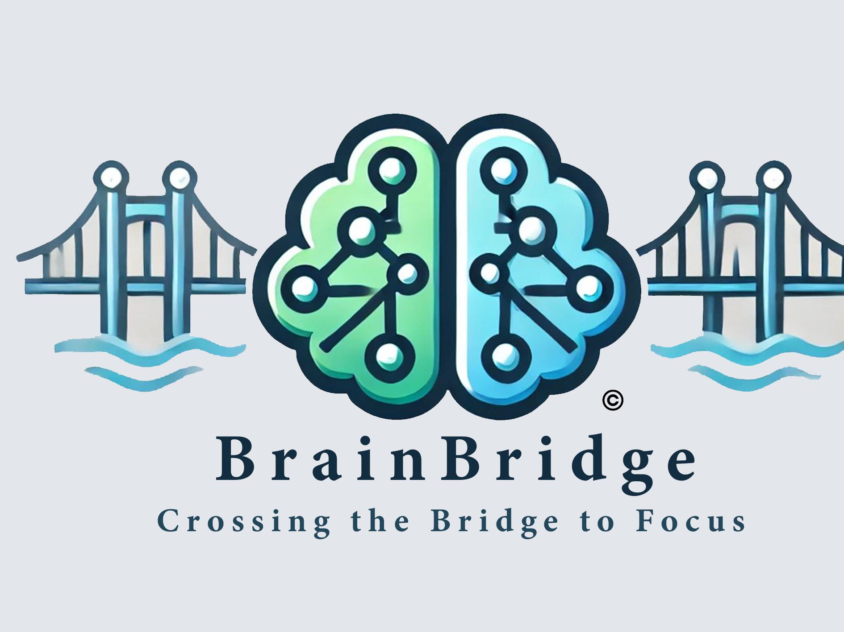

**Knizhnik Sandra & Adar Nil**

**Mentor: Dr.Natali Levi-Soskin**

## Abstract

In response to challenges posed by digital distractions and the rising prevalence of attention difficulties among school-aged children, this project introduces a comprehensive application designed to assist educators, parents, and students in managing and improving focus and attention-related behaviors. Developed for mobile and desktop platforms, the application leverages React Native for a seamless cross-platform user experience and Python for robust backend services, with MongoDB supporting dynamic and scalable data interactions. Central to the application's functionality is the creation of personalized programs that utilize individual data to tailor interventions specifically to each student's needs. These interventions incorporate recommendations for nutrition, physical activity, and classroom environmental adjustments to optimize the learning conditions for students with attention disorders.

The application features a unique task management system designed to stimulate dopamine release, enhancing engagement and reward sensations for the user. It also includes a parent-teacher chat feature to facilitate ongoing communication and collaboration. Real-time feedback, gathered through assessments, surveys, and progress tracking, is integrated into the system to refine and improve the interventions continuously. With accessibility features like multiple languages and customizable modes, the application ensures an inclusive experience for users from diverse backgrounds.

This project is an ongoing development, with future enhancements planned to integrate the NODUS ADHD detection tool, providing a structured diagnostic framework within the system. The tool will be translated into Hebrew, ensuring accessibility for a broader audience.

To ensure data security, users will log in using a unique ID and username to protect sensitive information. By providing a platform for early detection and ongoing management of attention disorders, the system aims to enhance educational outcomes, reduce stress, and foster better collaboration between home and school.

**Key Words:** Attention Difficulties, Personalized Educational Programs, Real-time Feedback, Cross-Platform Application, Educational Technology, Attention Management, Personalized Learning, Behavioral Analytics, User Engagement, Interactive Assessments.

# Table of content:

Abstract 2

**Table of content: 3**

1.Introduction 4

2.literature review 6

2.1 Introduction and Historical Background 6

2.2Neurobiological Insights and Environmental Influences 7

2.3 Impact of Lifestyle and Psychological Factors 7

2.4 Gender Differences and Societal Impact 9

2.5 Treatment and Management Strategies 11

2.6 Gamification 12

2.7 Computer-Based Tools for ADHD Treatment 12

2.8 Design thinking 13

2.9 Dopamine 14

3. Expected Achievements 14

4. Engineering Process 15

5. Product 19

5.1 System Requirements 19

5.1.1 Functional 19

5.1.2 Non-Functional(NFR) 19

5.2 The Algorithm 20

5.3 Diagrams 22

5.3.1 Architecture 22

5.3.2 Use Case 22

5.3.3 Sequence diagram of “login and ask for results of assessments and recommendations” 23

5.3.4 Activity diagram of “Login “ process of the system 24

5.3.5 Activity diagram of “main process” of the system 25

5.3.6 class diagram of “main process of the system 26

5.4 The application 27

5.5 Mockups screens 29

5.5.1 Home pages 30

5.5.2. Calendar and Schedule View: 31

5.5.3 Daily Planner and Activity Tracker 32

5.5.4 Watch recommendations 34

5.5.5 Nutritional Recommendations 36

5.5.7 Login & Register screen 39

6. Testing plan 40

7. Design thinking - appendices 42

8. Questionnaires 47

9. ChatGpt conversations 53

References 58

## 1.Introduction

In today's digital age, platforms like TikTok and Instagram create rapid dopamine feedback loops, making it difficult for children to maintain focus in educational settings.[1] This digital overstimulation leads to significant attention challenges[2], further exacerbated by the lack of effective tools for teachers to diagnose and manage these issues.[3] Children with ADHD, in particular, struggle with time management and organizing assignments, often resulting in academic failure and feelings of inadequacy.[4] Parents may not always be aware of these struggles until academic reviews or parent-teacher conferences, by which time the child may already be significantly behind.[5]

Addressing this gap can greatly improve the learning environment, reduce stress for teachers, and help children—especially those with ADHD—thrive in school and beyond.

Recognizing the need for better resources, several tools have been developed to assess and address various challenges related to attention and behavior:

1. **Child Behavior Checklist (CBCL):** Provides a list of behavioral traits to assess emotional, behavioral, and attention issues, including a subscale for ADHD [6].
2. **American Academy of Pediatrics (AAP) ADHD Toolkit:** A clinician's guide with resources for diagnosing, evaluating, and treating ADHD in children and adolescents, including an interactive treatment algorithm [7].
3. **Time Timer** : App for time management, allowing children to see how much time is left for a task. Helps to better manage activities and reduce anxiety over time limits​ [8]
4. **Behavior Assessment System for Children (BASC):** A system used to identify a wide range of behavioral and emotional traits in children and adolescents, helping professionals better understand their challenges.[9]
5. **Behavior Rating Inventory of Executive Function (BRIEF):** Parent-report tool to assess executive functions, covering areas like inhibition, emotional control, and planning, providing summary scores [10].

While these tools provide valuable insights into diagnosing and managing attention difficulties, they are often designed for use by health professionals or require extensive training to implement effectively. Many of these solutions are not directly accessible to teachers for everyday use in the classroom, leaving a gap in addressing attention-related challenges in real-time.

In our work, we aim to support teachers in managing attention difficulties by developing an interactive tool that allows them to log in with a username and password to effectively manage their different classes. Within this system, teachers will have the ability to identify students with concentration difficulties using a combination of methods. These include a tailored questionnaire for attention disorders, existing diagnostic tools, and teacher-provided observations. The system will analyze the inputs from external diagnoses, the questionnaire, and built-in tools to identify potential concentration difficulties and provide insights.

Once potential difficulties are identified, the system will offer the teacher a set of tailored strategies to better engage and support the student. Additionally, the system integrates a comprehensive time management tool and provides a visually engaging and easy-to-follow schedule for each student, enhancing daily planning and helping students manage their time effectively. If the child's concentration improves, the teacher can update the system, which will adjust the recommendations accordingly to ensure the strategies remain relevant and effective. While these tools provide valuable insights into diagnosing and managing attention difficulties, they often lack real-time adaptability and accessibility for teachers in everyday classroom settings. To bridge this gap, our system integrates structured progress-monitoring questionnaires, completed by teachers, parents, and students. These assessments provide real-time insights into academic performance, behavior, physical activity engagement, andresponse to interventions, enabling dynamic adjustments to recommendations. By incorporating this continuous feedback loop, our system ensures that strategies remain relevant and personalized to each student’s needs. By offering teachers this structured tool, they will be better equipped to address the unique needs of their students, improving their focus and performance in class.[11] This improvement will also indirectly benefit parents, as the child’s success in school can lead to reduced frustration and more confidence at home.[12] In the long term, this solution aims to create a more supportive learning environment for students, reduce stress for teachers by offering clear strategies, and positively influence the child’s overall development and relationships.

The proposed tool may be used by parents, children, and teachers to address and manage concentration difficulties effectively. Parents may use the tool to better understand their child's needs, reduce frustration, and improve communication. Often, children’s struggles with concentration can lead to frustration that spills over into the home environment, causing tension and potentially harming the parent-child relationship. By offering insights into the child’s needs and providing strategies for support, the tool helps parents foster a more positive and supportive dynamic at home.

Children may benefit from the tool as it helps them face challenges in school by improving their focus and confidence. Many children with concentration difficulties, such as ADHD, want to succeed but find it hard to stay focused or sit still, which can lead to poor grades, frustration, and even social difficulties. These struggles often lower self-confidence and can have long-term effects into adulthood.[12] The tool provides tailored strategies that empower children to perform better academically and socially, while also building their self-esteem.

Teachers, who play a crucial role in supporting students with attention difficulties, can use the tool to track progress and evaluate the effectiveness of their teaching methods. Managing a classroom with diverse needs is challenging, and concentration difficulties can disrupt the learning environment. This tool offers personalized tips and actionable strategies to help teachers handle specific situations, enabling them to better support their students while maintaining focus on teaching objectives. Additionally, the system integrates a comprehensive time management tool and provides a visually engaging and easy-to-follow schedule for each student, enhancing daily planning and helping students manage their time effectively. Furthermore, for students, especially those with conditions like ADHD, the tool offers tailored strategies that enhance academic and social performance, boosting self-esteem and addressing long-standing challenges[13]. By monitoring student progress, teachers can adjust their approaches and ensure that their methods remain effective[14]. By addressing the needs of these three groups, the tool creates a supportive environment where children can thrive academically and socially, parents can feel more connected to their child’s growth, and teachers can manage their classrooms more efficiently and confidently.

This document is structured into several chapters: Chapter 1 introduces the challenges and the need for attention management tools in education. Chapter 2 provides a literature review covering neurobiological insights, environmental influences, and digital media effects. Chapter 3 outlines the project's expected achievements. Chapter 4 describes the engineering process, including design methodologies. Chapter 5 presents the algorithm. Chapter 6 details the product, including system requirements, architecture, and diagrams. Chapter 7 focuses on the application’s design and usability, with mockups and user interface descriptions. Chapter 8 discusses the testing plan to ensure functionality and user satisfaction.

## 2.literature review

### 2.1 Introduction and Historical Background

DHD, or Attention-Deficit/Hyperactivity Disorder, is a neurodevelopmental condition characterized by persistent patterns of inattention, hyperactivity, and impulsivity that interfere with daily functioning . The concept of ADHD has evolved since the late 18th century when Scottish physician Sir Alexander Crichton first described symptoms of inattentiveness and restlessness. The changes in the DSM from recognizing 'Attention Deficit Disorder (ADD)' in 1980 to renaming it 'ADHD' in 1987 mirror our deepening understanding of the disorder. As our knowledge has expanded, the diagnostic terms and criteria have similarly evolved. Today, ADHD is recognized globally as a common neurodevelopmental disorder affecting both children and adults[15]. ADHD is now acknowledged as a prevalent condition, affecting 5-10% of school-aged children globally [16]. Of these, approximately 60-70% carry the disorder into adulthood [17], translating to 4-7% of adults experiencing symptoms [18]. ADHD is recognized as a complex condition that can manifest in different ways. The symptoms can stem from biological factors or be influenced by environmental conditions. Understanding these different origins helps in developing appropriate support strategies and interventions.

### 2.2 Neurobiological Insights and Environmental Influences

Neurobiological Insights and Environmental Influences is characterized by inherent neurobiological differences in brain structure and function, particularly in areas related to executive functioning, attention regulation, and impulse control. Neuroimaging studies reveal these differences influence neurotransmitter systems, notably dopamine and norepinephrine [19]. Conversely, **symptomatic attention difficulties** are becoming increasingly observed in modern society. Unlike physiological ADHD, which is rooted in neurobiological differences, symptomatic difficulties primarily arise from environmental and lifestyle factors. These challenges have escalated in prevalence over the past decade, particularly among younger individuals exposed to prolonged digital stimulation. Research highlights that constant engagement with digital media, social networks, and rapid content consumption alters neural reward pathways, leading to symptoms that closely resemble ADHD. Digital overstimulation is a significant contributor to symptomatic attention difficulties. In the modern era, dominated by digital devices such as smartphones, tablets, and computers, individuals are often required to multitask extensively. Frequently switching between apps, notifications, and platforms fragments attention spans and reduces the ability to maintain prolonged focus. Studies indicate that individuals who spend more than six hours daily on digital devices are significantly more likely to report attention-related challenges compared to those with limited screen exposure [20]. This constant demand for rapid processing of fragmented information creates a cycle of overstimulation, making it harder for the brain to engage in deep, sustained focus.

### 2.3 Impact of Lifestyle and Psychological Factors

Excessive screen time, linked to diminished focus capacity, is exacerbated by the blue light from screens, which suppresses melatonin production, impairing sleep quality. Adolescents, who are particularly prone to irregular sleep patterns, are twice as likely to experience attention difficulties compared to their peers with consistent sleep schedules [21]. This connection underscores the importance of maintaining regular sleep routines as a foundational strategy for addressing attention challenges. Environmental and psychological stressors, including anxiety and depression, also play significant roles in exacerbating attention difficulties, modern learning and working environments often bombard individuals with simultaneous stimuli, ranging from notification sounds to visual alerts. These distractions create cognitive overload, making it challenging to maintain focus on a single task[22].

Psychological factors such as anxiety, depression, and chronic stress significantly contribute to attention difficulties. Research indicates that nearly half of individuals with attention challenges also experience concurrent psychological conditions, emphasizing the complex interplay between mental health and attention regulation. This overlap is crucial, as emerging evidence suggests that stress and anxiety not only exacerbate attention problems but also correlate with inflammation, which can further affect neurodevelopmental outcomes. Addressing these psychological and physiological aspects simultaneously is essential for effective intervention and support in managing symptomatic attention difficulties.[23]

The manifestation of these difficulties varies significantly across different life stages. For children aged 6 to 12, the challenges often revolve around academic and social skills. Research indicates that children with ADHD frequently struggle with peer interactions, impacting their ability to follow instructions and participate effectively in structured activities like classroom learning and play. This can lead to social isolation and academic challenges as these children may miss important social cues and feedback from peers and adults, leading to fewer opportunities to practice and develop social skills. Sycamore’s study emphasizes how ADHD impacts children’s social development through peer rejection, noting that these struggles can significantly hinder both academic performance and social development, thus underscoring the importance of early interventions to mitigate these challenges​[24].

Adolescents face a distinct set of challenges during the transitional phase from childhood to adulthood. The increased academic pressures, coupled with significant neurological and hormonal changes, can amplify attention-related difficulties. The pervasive influence of social media adds another layer of complexity, creating an environment where teenagers feel relentless pressure to keep up both socially and academically. The constant exposure to peer comparisons and the fear of missing out (FOMO) can intensify feelings of inadequacy and anxiety. These factors collectively contribute to difficulties in concentrating on studies and managing long-term projects, necessitating tailored support strategies to navigate these challenges effectively. Research suggests that a substantial number of adolescents with attention challenges struggle with managing their social media use effectively, which can distract them from academic tasks and heighten stress. In dealing with these compounded pressures, tailored support strategies that address both the psychological impacts of social media and the developmental changes during adolescence are crucial for helping teenagers navigate these turbulent years more successfully​. ​[25]

The transition to higher education introduces additional challenges for college students, particularly for those with attention difficulties. The lack of structured support systems, which are more common in earlier educational stages, leads these students to frequently struggle with time management, self-directed learning, and maintaining focus during lectures. Studies have identified that university students with ADHD symptoms experience significant difficulties in academic performance, managing daily routines, and interpersonal relationships, which can impact their ability to complete assignments and manage long-term projects effectively.[26]

In professional settings, adults with ADHD encounter significant obstacles, particularly in task management, adhering to deadlines, and sustaining focus during prolonged meetings. These challenges are often characterized by clinical features such as impulsivity and restlessness, which hinder career progression and can lead to slower professional advancement. Furthermore, ADHD in adults is frequently associated with difficulties in life management skills, including financial planning and maintaining consistent budgeting practices. These challenges extend to family life, where adults with ADHD struggle with coordinating household routines and supporting their children’s educational needs, reflecting the need for tailored interventions that address both professional and personal life management for adults with ADHD. [27]

### 2.4 Gender Differences and Societal Impact

Significant gender differences in ADHD presentation influence diagnosis and treatment. Research has shown that ADHD manifests differently in males and females, contributing to disparities in how they are diagnosed and treated. Women often display predominantly inattentive symptoms, such as difficulty sustaining attention, forgetfulness, and a tendency to appear disengaged or "daydreaming." These symptoms can lead women to mask their struggles, blending into social and academic environments to avoid stigma. This masking behavior often delays diagnosis and intervention, which can prolong the difficulties they face in managing symptoms. Additionally, women with ADHD are more likely to experience co-occurring conditions like anxiety and depression, which can complicate their treatment plans. For example, it has been noted that emotional dysregulation such as anxiety is more commonly reported among women with ADHD compared to their male counterparts.[28]

Conversely, men with ADHD are more frequently diagnosed due to the more visible and disruptive nature of their symptoms, such as hyperactivity and impulsivity. These symptoms often lead to earlier identification but may also result in more severe disciplinary measures. For instance, studies have shown that boys with ADHD are significantly more likely to face disciplinary actions in educational settings, such as suspensions or expulsions.[29]

Neurological studies have also highlighted differences in brain regions affected by ADHD between genders, with women showing variations in areas associated with emotional regulation and executive functioning, while men exhibit more pronounced differences in regions linked to motor control and impulse regulation. These differences underscore the need for gender-sensitive diagnostic criteria and treatment interventions that are tailored to the distinct challenges faced by each gender, acknowledging the unique presentations and needs of males and females with ADHD. Neurological studies provide further insight into these gender differences. Women with ADHD often show differences in brain regions associated with emotional regulation and executive functioning, while men exhibit more pronounced differences in areas related to motor control and impulse regulation. These distinctions may partly explain why men are more likely to exhibit externalizing behaviors, such as hyperactivity, whereas women often struggle internally with inattention and emotional dysregulation . Cultural and societal expectations also contribute to the underdiagnosis and misdiagnosis of ADHD in women. Cultural norms often expect boys to be active and outspoken, which can normalize hyperactive behaviors to some extent. Meanwhile, girls are socialized to be compliant and attentive, making inattentive symptoms less apparent and more likely to go unnoticed by teachers or caregivers. Addressing these biases is crucial for ensuring equitable access to diagnosis and support services . Moreover, hormonal fluctuations unique to women introduce additional complexities. Changes during puberty, menstrual cycles, pregnancy, and menopause can exacerbate ADHD symptoms, often leading to inconsistent performance and heightened emotional responses. These hormonal influences make it essential to develop tailored interventions that account for the unique challenges faced by women across their lifespan [30].

Men, on the other hand, face societal pressures to excel in academic and professional settings, which may exacerbate the impact of ADHD-related impairments. Their more overt symptoms often lead to earlier interventions, but these interventions may not always address the full spectrum of their needs, particularly in emotional and social domains. This gap in treatment responsiveness underscores the necessity for interventions that are as attentive to the social and emotional challenges as they are to the overt symptoms. The long-term outcomes for men and women with ADHD also differ significantly. While both genders may struggle with career advancement, women are more likely to report difficulties balancing work and family responsibilities due to their ADHD symptoms. Conversely, men often face challenges related to managing workplace expectations and maintaining interpersonal relationships. This disparity highlights the critical need for understanding these gender-specific manifestations to design effective support systems . Tailored approaches that consider both biological and social influences are essential for improving outcomes and ensuring that individuals receive appropriate care. These considerations extend to treatment strategies, which must address both the core symptoms of ADHD and the unique challenges faced by different populations.[31]

### 2.5 Treatment and Management Strategies

Pharmacological treatments remain foundational in managing ADHD by regulating brain activity and neurotransmitter pathways, with a significant proportion of patients experiencing symptom reduction. Medications such as Ritalin and Attent aim to improve concentration, reduce hyperactivity, and control impulsive behaviors by regulating brain activity. These interventions target neurotransmitter systems, particularly dopamine and norepinephrine pathways, providing significant daily functioning improvements. As a result, pharmacological interventions are a cornerstone of ADHD management, integral to personalized treatment plans that address the diverse needs of individuals with ADHD [32]

Despite their effectiveness, these treatments are not without challenges. Adherence to medication regimens can be difficult, particularly for children and adolescents, and adverse effects such as appetite suppression, sleep disturbances, and mood changes are common. Moreover, the process of identifying the most effective medication and dosage for an individual often involves trial and error, which can be time-consuming and frustrating. Racial and ethnic disparities further complicate access to and outcomes of pharmacological treatments, highlighting the need for equitable healthcare practices that address these systemic barriers. In addition to the proven effectiveness of these medications for treating ADHD, studies show that 80-85% of patients using ADHD medications experience significant improvement in symptoms. However, the primary issues with medication treatment for ADHD are adherence challenges, adverse effects, complexity in finding the right medication, and racial and ethnic disparities[33]

Proper nutrition may play a significant role in managing ADHD symptoms, with some research [34] suggesting that minerals and probiotics can improve symptoms. There are also additional studies indicating a link between omega-3 consumption and the alleviation of ADHD symptoms. Moreover, other dietary supplements, such as zinc, iron, magnesium, and vitamin D [35] have shown potential benefits in managing ADHD symptoms through their impact on brain health and cognitive function. However, it's important to note that while these dietary interventions can be helpful, they may not be sufficient on their own to fully address the complexities of ADHD. A comprehensive approach that includes behavioral therapy, medication, and lifestyle changes is often necessary for effective management. Additionally, dietary changes do not work for all children with ADHD, and it is crucial to consider individual differences when determining the best course of treatment.[36]

Physical activity has been increasingly recognized as a beneficial intervention for managing ADHD symptoms. exercise has been shown to improve attention, reduce hyperactivity, and enhance cognitive functioning in children with ADHD [37]. The review of literature indicates that aerobic exercises, such as running, cycling, and swimming, can significantly improve executive functions, including working memory, cognitive flexibility, and inhibitory control. Moreover, participation in structured physical activities provides children with opportunities to develop social skills, build self-esteem, and reduce anxiety and depression, all of which contribute to better overall management of ADHD symptoms. However, despite these benefits, there are challenges related to maintaining regular physical exercise, particularly for children with ADHD. Issues such as adherence to a regular exercise routine and individual differences in response to physical activity can impact the effectiveness of this intervention.

### 2.6 Gamification

Gamification involves the use of game design principles in non-game contexts to enhance user engagement, motivation, and participation[38]. In ADHD management, gamification employs challenges, rewards, and progress tracking to help users stay focused, achieve goals, and maintain motivation. Apps that incorporate gamification elements, such as earning points, leveling up, and completing tasks, can provide individuals with ADHD a sense of accomplishment and encourage them to complete tasks they may struggle with. The effectiveness of gamification in managing ADHD is supported by studies indicating that the use of game elements can improve motivation and increase engagement [39]. For example, research has found that gamification interventions may enhance persistence in tasks and encourage children with ADHD to stay engaged in their activities. However, gamification alone is not always sufficient for all users. While it provides immediate motivation, its long-term effectiveness depends on its integration with other treatments, such as Cognitive Behavioral Therapy (CBT) or medication. Additionally, the benefits of gamification may be limited by the users interest in the game and their ability to maintain consistency over time.[40]

### 2.7 Computer-Based Tools for ADHD Treatment

There are many computer-based tools available today that help manage ADHD. These include apps, software, and cognitive games that focus on improving skills like concentration, working memory, and impulse control. For example, apps like **Todoist** help people with ADHD organize and plan their daily tasks[41]. There are also cognitive training games that provide exercises to improve working memory and problem-solving abilities [42]. Additionally, the ADHD Behavior **Toolbox** app provides parents and educators with specific strategies to manage challenging behaviors associated with ADHD. It offers solutions for common behavioral concerns such as aggression, impulsivity, anxiety, and social difficulties, helping to improve both emotional regulation and core skills [43]. In addition to these tools, there are also apps focused on improving emotional regulation and behavioral control. For example **Breethe**, a mindfulness and meditation app, helps users with ADHD practice mindfulness techniques to manage stress and improve focus[44] . Another useful tool is **Mindful Powers**, which is specifically designed for children and helps them develop emotional regulation skills through interactive activities [45]. Another tool is **Seesaw,** an app that allows teachers to track students progress and provide immediate feedback. It helps students with ADHD stay organized by providing a clear, visual platform for assignments and tasks. Teachers can monitor each student's work and provide personalized feedback, helping students manage their time and responsibilities effectively. This real-time interaction ensures that students receive the support they need to complete their assignments and develop better organizational skills. By promoting a structured and engaging learning environment, Seesaw helps students with ADHD manage their academic responsibilities more effectively[46].

Even though these tools still need to be part of a broader treatment plan that includes professional guidance, as they do not provide a comprehensive solution on their own. Integrating these digital tools with traditional therapies such as cognitive behavioral therapy (CBT) or medication can provide a more balanced and effective approach to managing ADHD symptoms. Although these computer based tools can be helpful, they present several challenges that limit their effectiveness as a standalone solution for treating ADHD. These tools require consistent use, which can be difficult for children with ADHD without external support . Additionally they primarily address cognitive skills like attention but do not manage emotional or behavioral issues, which are also significant aspects of ADHD. Research indicates that combining digital tools with traditional treatments, such as (CBT) or medication, can provide a more balanced and effective approach to managing ADHD symptoms. For example, integrating digital tools with CBT has been shown to be particularly effective, as CBT alone can be almost as effective and continue to improve over time, while medication treatment alone may have certain limitations. [47]

### 2.8 Design thinking

Design thinking is a methodology used to solve complex problems and create innovative solutions, emphasizing a user-centered approach and leveraging multi-disciplinary team collaboration. The process is structured into three overlapping spaces—viability, desirability, and feasibility, which collectively foster innovation when addressed simultaneously.[48]

The key stages of design thinking include:

1. Empathize (Interview and empathy maps): Direct interaction with users to gain a deep understanding of their needs and challenges.
2. Define (persona): Clearly articulating the problem based on insights gained during the empathy stage.
3. Ideate: Generating a wide range of ideas and solutions through creative and divergent thinking.
4. Prototype: Rapidly creating iterations of solutions to visualize and test their functionality.
5. Test: Refining prototypes based on feedback from users to ensure the solutions meet their needs effectively.

This structured approach enables teams to address complex "wicked" problems by integrating diverse perspectives, leading to more comprehensive and innovative solutions. The process not only supports idea incubation but also enhances the effectiveness of team collaboration, crucial for driving innovation in various organizational contexts.[48]

### 2.9 Dopamine

Dopamine is a monoamine neurotransmitter that plays a significant role in numerous neurological processes, influencing functions such as movement, motivation, and reward-related learning. Dopamine release in the brain is mediated through a process of exocytosis of dopamine-containing vesicles. This release is triggered by neuronal activity that prompts the opening of calcium channels, leading to an influx of calcium ions into the neuron. Localized dopamine release can create "hotspots" of signaling, where dopamine impacts target cells in its immediate vicinity [49].

Furthermore, dopamine also significantly affects the immune system. Dopamine is involved in the communication between the nervous and immune systems, utilizing specific receptors and transport systems in white blood cells. This involvement suggests that dopamine's roles in the immune system contribute substantially to the body's response to diseases and environmental stresses [50].

## 3. Expected Achievements

Our system will create a platform designed to significantly enhance the educational environment by integrating tools that benefit teachers, students, and parents alike. By improving class management and providing consistent educational strategies across different schools, teachers will be equipped with the resources needed to recognize and address students' concentration challenges effectively. This will enable them to tailor their teaching methods to better support individual learning needs, thereby making the classroom a more focused and welcoming space.

Students will gain significantly from our system, which provides a supportive environment that boosts their academic performance and helps them manage their assignments confidently. By using features like interactive to-do lists and surveys, students can stay on top of their studies more effectively. This reduces their academic anxieties, making them feel less like outsiders due to their academic struggles. As a result, they become more successful in their studies, which decreases their social isolation and makes them feel more integrated with their peers. With academics under control, students will have more time and energy to invest in social interactions, further enhancing their school experience.

Parents will play a crucial role in this new system by being kept in the loop about their children’s educational progress through regular updates and insights into the strategies being used in the classroom. This level of involvement ensures that parents are not just observers but active participants in their children’s education, which is essential for fostering an encouraging home environment that complements the educational efforts at school.

Together, these elements combine to create a dynamic educational system that supports students academically and socially, aids teachers in delivering more effective education, and keeps parents well-informed and engaged in their children's learning journey.

Our success will be measured by clear outcomes: we will test it on students and teachers at schools. We expect to see better grades for students, improved observations from teachers through regular surveys, and positive feedback from students and parents about the academic and social environment. We believe that the platform’s comprehensive approach will not only boost academic results but also improve the overall well-being of students, supporting a more dynamic and responsive educational system.

## 4. Engineering Process

The development of our project began with an in-depth exploration of attention disorders, where we recognized the diverse ways these manifest across different age groups and genders. This initial exploration set the stage for employing design thinking techniques, allowing us to systematically address these challenges through direct engagement with teachers, parents, and students.

**Empathize:** In the initial stage, our team engaged directly with teachers and students to understand their unique challenges and needs concerning attention difficulties. Through interviews and empathy maps, we gained deep insights into the day-to-day struggles of managing attention disorders in educational settings. This direct interaction helped us pinpoint key areas that required innovative solutions, setting a strong foundation for our project.[Interviews,Empathy map]

**Define:** To address the lack of structured progress-tracking tools, we designed customized questionnaires[Questionnaires] tailored for:

1. Teachers – To assess student engagement, focus levels, organization, and classroom behavior over time.
2. Parents – To monitor their child’s daily routines, adherence to recommendations, and behavioral patterns at home.
3. Students – To provide self-reported insights on their focus, energy levels, and perception of learning strategies.

These questionnaires were developed based on:

* Scientific research on ADHD and attention management strategies.
* Last year’s capstone project, which emphasized the importance of continuous feedback loops in improving attention management.
* Educator interviews, ensuring real-world applicability in classroom settings.

To ensure these questionnaires accurately capture user needs, we grounded their development in detailed user personas, such as Marina (a teacher) and Itai (a student). Marina requires a tool to efficiently track student progress and tailor interventions, while Itai benefits from engaging, structured feedback mechanisms. By integrating these personas, we ensured the questionnaires provide actionable insights, dynamically informing teachers, parents, and students about intervention effectiveness and progress tracking.[persona]

**Ideate:** With a clear understanding of our users' needs, we employed divergent thinking to brainstorm a wide array of creative solutions. Initially, our focus centered on developing a system that could manage detailed information for each child, allowing teachers to track and adapt educational strategies effectively. This concept extended to the creation of interactive games tailored to specific subjects, which could be either teacher-directed or automatically generated based on the child's preferences and needs. As we delved deeper, we considered enhancing these games with mechanisms to boost dopamine levels at the start of lessons, thereby preparing students for learning by making them more attentive and receptive. This approach was driven by our understanding that poorly absorbed dopamine is a direct link to attention disorders, and enhancing dopamine levels could significantly improve concentration. However, after reviewing existing literature, we discovered that interventions using games to boost dopamine were already in place, although not specifically tailored to educational content or integrated directly into classroom activities. This revelation prompted us to think more broadly about how we could innovate beyond existing solutions. We brainstormed various approaches, including systems that combine real-time data tracking with interactive, dopamine-releasing games tailored to curriculum needs.

**Prototype:** Our ideas were then brought to life through the development of initial prototypes. These included mockups of the application’s user interfaces, designed to provide intuitive and responsive interactions for teachers, students, and parents. These prototypes were essential for visualizing how the end-users would navigate and utilize the features of our application.[6.1 Mockups screens] Further research and empathy mapping for teachers and students highlighted the broader impact of attention disorders. We identified significant challenges for teachers, including managing large classes and dealing with burnout, which often resulted in a lack of patience and personalized attention to students who needed it most. This insight shifted our focus towards providing tools for teachers to diagnose and adapt their teaching strategies to better accommodate these students. We decided to integrate diagnostic tools into the system that would help teachers identify attention disorders, enhanced by the capability to update diagnoses based on continuous assessment through structured questionnaires. This dynamic approach not only provides initial assessments but also allows for ongoing evaluations, adapting the educational strategies as needed based on the evolving understanding of each student's condition. Furthermore, recognizing the critical role of actionable insights in educational settings, our system also provides coping strategies tailored to the diagnosis results. These strategies are designed to assist teachers in addressing specific challenges identified through the diagnostic process, thereby enabling them to offer more effective and individualized support to each student. This proactive approach ensures that interventions are not only timely but also aligned with the best educational practices tailored to students' unique needs. By addressing the needs of teachers with these comprehensive diagnostic and intervention tools, we inherently benefit the students by providing them with a supportive, understanding, and adaptable educational environment. The system also keeps parents well-informed and engaged by allowing them to track their children's progress and understand the coping strategies being implemented, thus ensuring a collaborative approach to education that involves educators and families alike. This ongoing feedback loop, facilitated by the system, not only keeps all stakeholders informed but also empowers them to participate actively in the educational and developmental process, making it a collective effort to support students with attention disorders.

Throughout this project, the principles of gamification played a crucial role. Based on our research, incorporating gamification could significantly enhance engagement and focus, which was particularly beneficial for managing time and tasks. By applying these principles, we aimed to create a system that not only facilitates learning but also makes it a more enjoyable and engaging process. As we delved deeper into the development of our project, one of the pivotal decisions we faced was the choice of platform for deploying our assessment and intervention tools. Considering the diverse needs of our user personas—busy parents, overloaded teachers, and children accustomed to digital interfaces—it became clear that accessibility and flexibility were paramount. These considerations led us to opt for a mobile application that could be accessed anytime and anywhere, ensuring constant availability which is crucial for our target users. Considering our user base, which includes digitally-savvy children accustomed to rapid and intuitive interfaces, a mobile application naturally emerged as the optimal platform for our project. This choice ensures that the application is accessible and engaging on the devices our users are most comfortable with. To efficiently handle the dynamic and sometimes unstructured data associated with tracking and assessing users with ADHD, we selected MongoDB as our database system. MongoDB's flexibility makes it well-suited for managing such data, allowing us to process information swiftly and adaptively. Additionally, MongoDB is one of the most popular systems in the industry today, and due to its widespread adoption, it has a supportive community and high standards of performance and maintenance, which are crucial for our application's demands. Our previous experience with MongoDB also enables us to fully leverage its capabilities and integrate it seamlessly with other system components, ensuring tailored and efficient solutions for our project's needs. Regarding the programming language, we chose Python for the backend development and React Native for the frontend. Python was selected because we have prior experience with the language, which is one of the most powerful and popular languages for app development. Our deep familiarity with Python will allow us to work quickly and efficiently, saving us valuable learning time for a language we are not familiar with. The language also provides access to many libraries that are available for it, enabling smooth processing of advanced data. Additionally, Python offers great synergy with MongoDB and helps us create tailored solutions in a simple and clear manner. Furthermore, we chose React Native for mobile app development, also because of its capabilities for web app development. Using React Native allows us to develop apps that are compatible with both mobile devices and browsers, ensuring a consistent and excellent user experience across platforms. The combination of React Native enables us to deliver a fast and efficient solution that works for all operating systems (iOS, Android, and Web), while maintaining a high user experience and great flexibility.

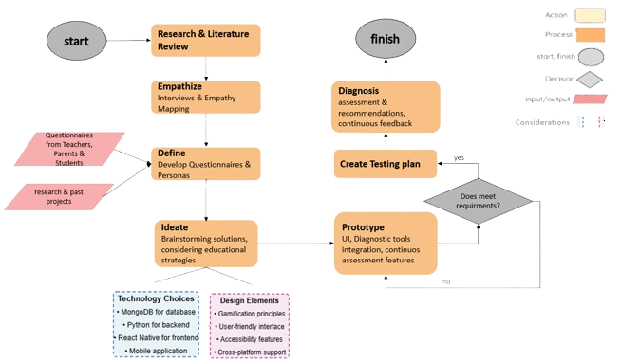

## 5. Product

## 5.1 System Requirements

### 5.1.1 Functional

1. The system shall enable secure registration and login for teachers, parents, and students.
2. The system shall provide interface in both Hebrew and English.
3. The system shall synchronize with the school database that include class, and family data.
4. The system shall enable creation of assessments for attention deficit .
5. The system shall track assessment history and versions
6. The system shall send automatic notifications to teachers and parents upon assessment completion.
7. The system shall enable sending progress questionnaires to parents
8. The system shall enable management of daily tasks for individual/groups of students
9. The system shall allow students to mark completed tasks
10. The system shall provide personalized recommendations based on disorder type
11. The system shall display statistical data on diagnosed students
12. The system shall enable export of reports.
13. The system shall integrate the NODUS ADHD detection tool to assist in structured ADHD diagnosis
14. The system shall provide a real-time chat feature for communication between teachers and parents
15. The system shall include structured questionnaires for teachers, parents, and students

### 5.1.2 Non-Functional(NFR)

1. Interfaces should be accessible and intuitive for all users, including children.
2. The system should integrate smoothly with external systems like Nodus.
3. The system must ensure the privacy and security of sensitive user information.
4. Assessment should be finished within a short time .
5. Recommendations provided by the system should be easy to understand.
6. Only authorized users can access sensitive data, based on their role
7. After crashes the system should recover within a reasonable time
8. Data can be exported in formats like CSV or PDF .
9. The system shall provide a seamless real-time chat experience with minimal latency.
10. Chat history shall be stored securely
11. The system shall update personalized recommendations based on progress questionnaire responses.

## 5.2 The Algorithm

**Algorithm Overview** To ensure the application provides tailored recommendations for students with attention difficulties, we developed a systematic algorithm that processes input data and generates actionable outputs.

The algorithm comprises the following stages:

1. **Data Collection**Information is gathered from two key sources:
   * The **Nodus app**, which provides a specific ADHD diagnosis and subtype.
   * **Questionnaire responses** completed by parents, teachers, and students.
2. **Data Analysis**The algorithm evaluates the collected data:
   * **If sufficient:** It generates a personalized plan covering three critical areas:
     1. Nutrition
     2. Physical activity
     3. Classroom behavior
   * **If insufficient:** It identifies missing data, notifies the user, and prompts them to provide the required information.

The system’s recommendation engine integrates responses from structured questionnaires to refine intervention strategies. Data from teachers regarding classroom behavior, parental observations on home routines, and student self-reports enable the algorithm to make dynamic adjustments. For example, if a student’s focus scores improve following increased physical activity, the system may reinforce that recommendation, ensuring interventions remain both effective and adaptable.

1. **Plan Generation**Once sufficient data is available:
   * A tailored recommendation plan is generated.
   * The program notifies the user that the diagnosis and recommendations are complete.
2. **Iterative Refinement**
   * Missing data is addressed through user prompts and reanalysis.
   * This cyclical process ensures recommendations remain accurate, actionable, and personalized.

Benefits of the Algorithm: The algorithm ensures the system’s recommendations are:

**Actionable and tailored:** Using specific ADHD subtypes and detailed inputs to address individual needs.

**Seamlessly integrated:** Allowing teachers, parents, and students to access real-time insights.

**Dynamic and adaptive:** Continuously refining recommendations based on updated input.

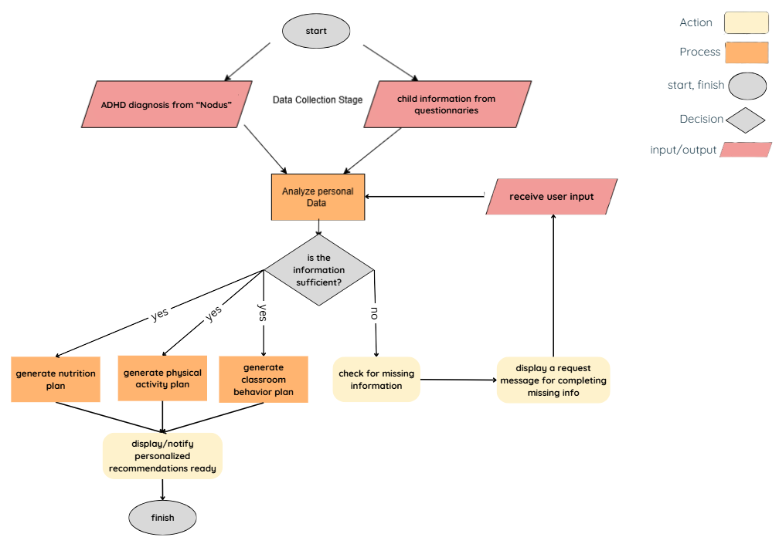

### 5.3 Diagrams

### 5.3.1 Architecture

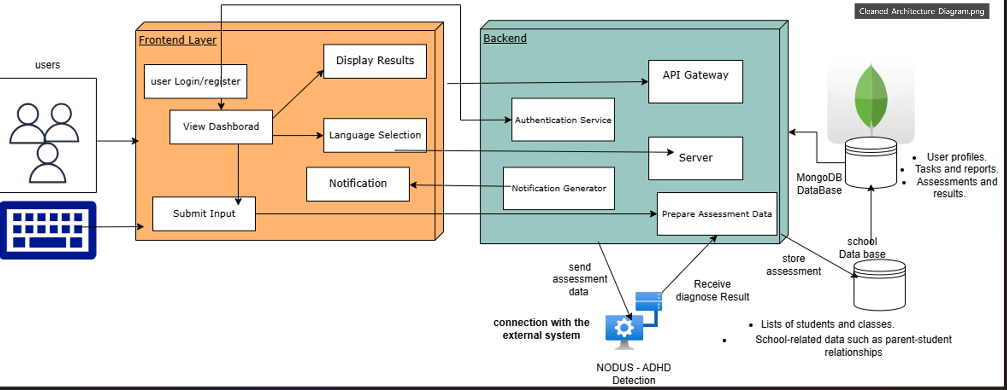

### 5.3.2 Use Case

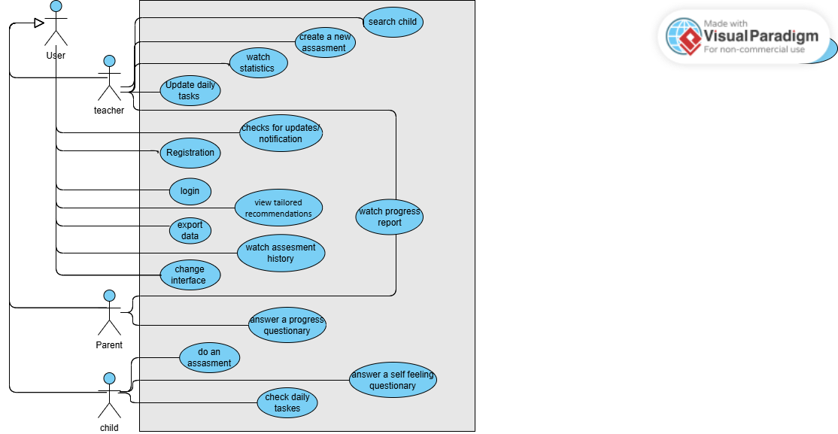

### 

### 5.3.3 Sequence diagram of “login and ask for results of assessments and recommendations”

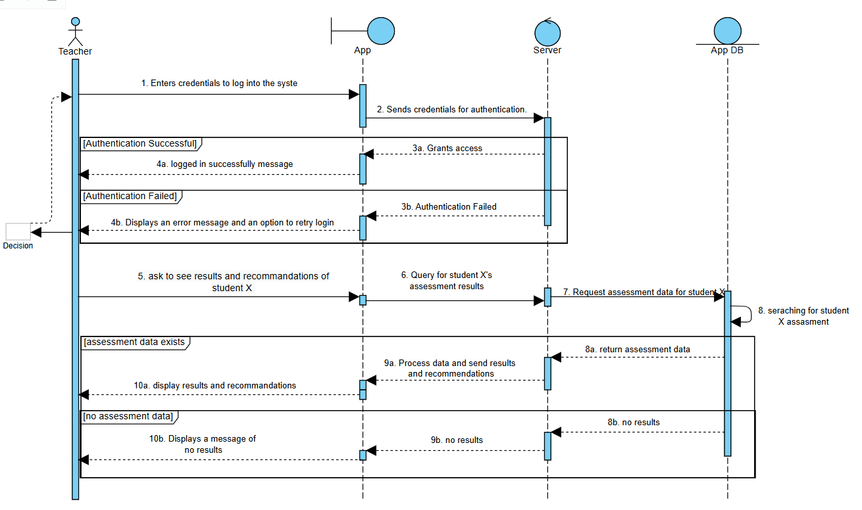

### 

### 5.3.4 Activity diagram of “Login “ process of the system

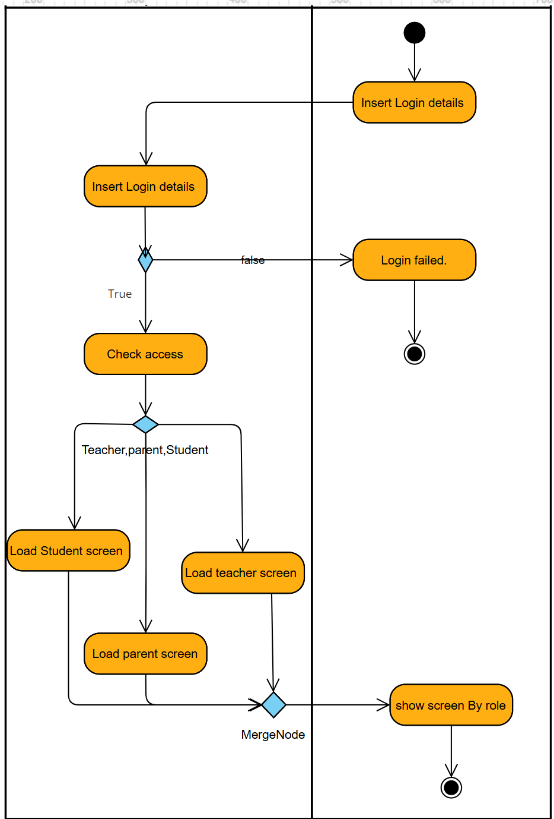

### 5.3.5 Activity diagram of “main process” of the system

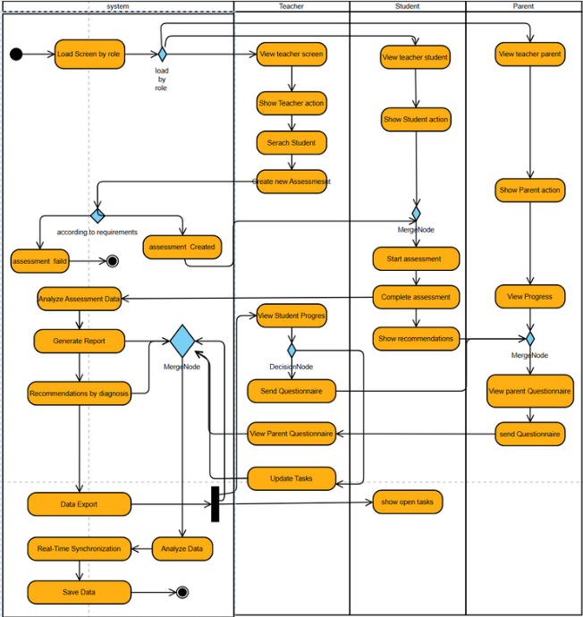

### 5.3.6 class diagram of “main process of the system

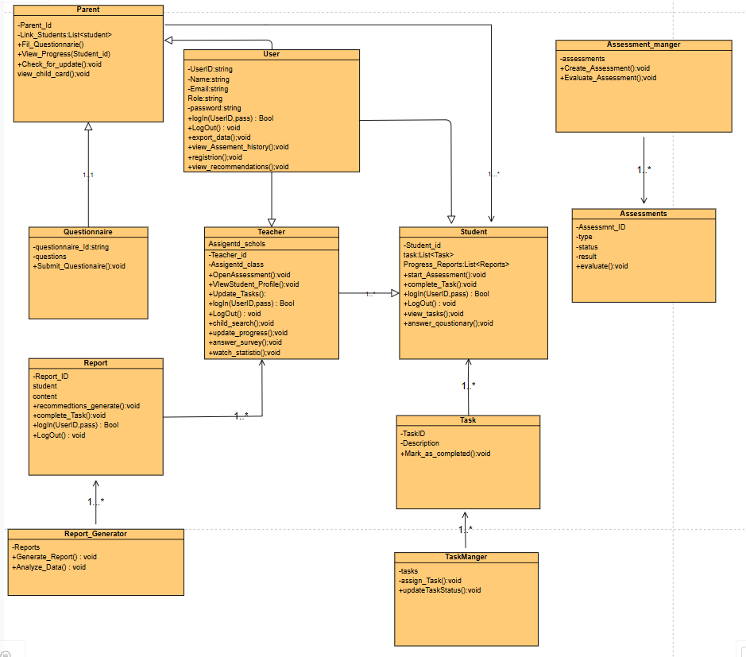

## 

## 5.4 The application

This section details the technical specifications and functionalities of the non-web application that forms the core user interface of this project. The application is designed to be accessible on both mobile devices and desktops, ensuring users can interact with the system seamlessly in various settings, including classrooms, homes, and on the go. Below are the chosen technologies, frameworks, and libraries used to construct the application, aiming to provide an intuitive, responsive, and educational user experience.

* **User-Centric Design for Streamlined Interaction**: Our application emphasizes intuitive navigation and ease of use to ensure that users can easily comprehend and interact with their educational data. The interface design is optimized for quick access to necessary features, enhancing both student and educator experiences.A key functionality is the **real-time parent-teacher chat**, which fosters direct communication and collaboration between parents and educators, allowing them to discuss student progress, clarify recommendations, and address concerns promptly.
* **React Native for Flexible Cross-Platform Development**: We chose React Native for the frontend to develop a responsive and adaptable application for both iOS and Android devices. React Native’s robust, component-based architecture allows for efficient updates and real-time data handling, essential for our application’s need to display frequent educational content and assessments dynamically.
* **Python for Robust Backend Services**: The backend of our application is powered by Python, chosen for its flexibility, efficiency, and wide array of libraries that enable the handling of complex educational data and real-time interactions. Python’s capabilities ensure that the backend can effectively manage web service requests, data processing, and seamless integration with MongoDB and WebSocket technology. This provides a reliable infrastructure for key features such as personalized recommendations, progress tracking, and the parent-teacher chat.
* **MongoDB for Dynamic Data Management**: To handle our application’s varied data inputs, MongoDB provides the necessary flexibility and scalability. Its non-relational structure allows us to store diverse data types from user interactions and educational content, facilitating quick retrieval and updates as user interactions evolve.
* **Real-Time Data Synchronization and WebSocket Technology**: Utilizing WebSocket for real-time communication ensures that the application remains up-to-date with instant updates and responses, crucial for maintaining user engagement and facilitating real-time educational feedback.
* **Enhanced Security Measures for Data Protection**: We are committed to the security and privacy of our users. The application will incorporate advanced encryption techniques and comply with the latest data protection regulations to safeguard sensitive information, ensuring a secure environment for all users.
* **Scalability and Reliability via Cloud Services**: Leveraging cloud services, such as AWS, enables us to scale resources according to user demand and ensures high availability, particularly during peak operational hours. This approach supports a reliable and uninterrupted user experience.
* **Accessibility and Inclusivity Features:** Recognizing the diverse needs of our user base, the application supports multiple languages, text resizing, and a switchable light/dark mode to accommodate various educational contexts and user preferences, ensuring a comprehensive and inclusive educational tool.

We aim to provide a seamless and effective educational tool through our non-web application, enhancing the learning experience for students and facilitating teachers in monitoring and supporting educational progress effectively. Detailed sketches and prototypes of the application interface will be provided in the following sections, illustrating the user journey and interaction with the system.

### 5.5 **Mockups screens**

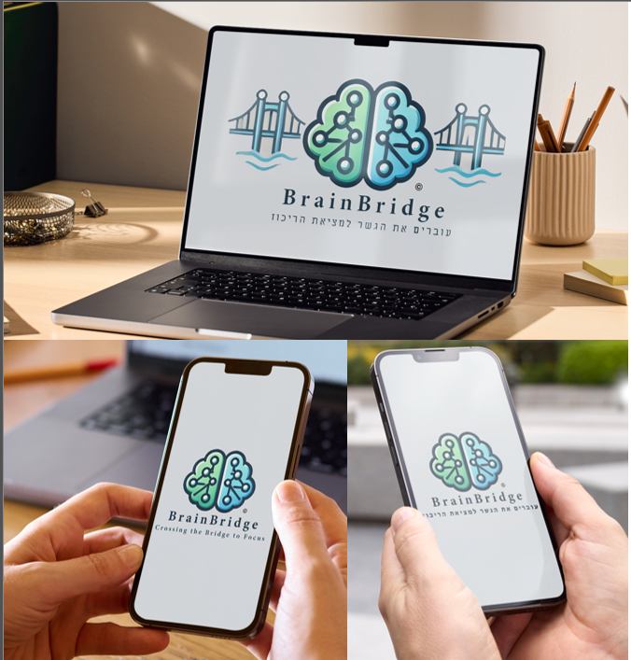

### 5.5.1 Home pages

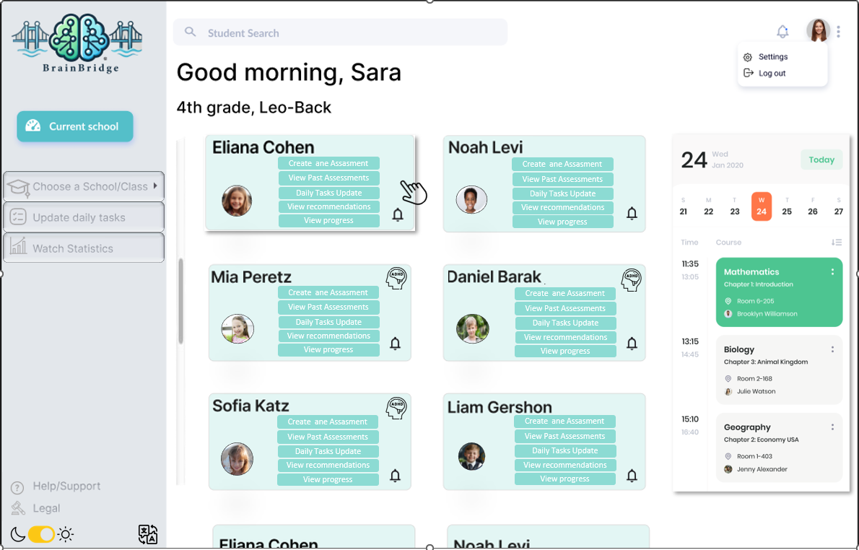

**Primary User:** The user of this screen is a teacher. The interface is customized to enable teachers to manage their classes effectively, track student progress, and handle daily educational tasks.

**Functionalities and User Capabilities:**

1. **Student Management Cards:** Each card displays a student's name and photo with quick action buttons for:

* **Create an Assessment:** Initiate ADHD-specific assessments to gauge progress or new concerns.
* **View Past Assessments:** Access historical data on previous ADHD assessments for each student.
* **Daily Tasks Update:** Add or modify daily structured tasks that help students with ADHD manage their schedules effectively.
* **View Recommendations:** Get tailored strategies based on the latest assessment results to support each student's unique needs.
* **View Progress:** Monitor and evaluate the student's academic and behavioral progress over time.

1. **Navigation and Accessibility:**
   * **Student Search Bar:** Positioned at the top, this feature enables teachers to quickly find students by name, enhancing the efficiency of managing large classes.
   * **Sidebar Navigation:**
     + **Choose a School/Class:** Quickly switch between different classes or schools.
     + **Update Daily Tasks:** Easily manage or input new tasks for the day.
     + **Watch Statistics:** Review statistical insights into the classroom's overall performance and individual student achievements.
     + **Help/Support and Legal:** Links at the bottom left offer support and legal information, ensuring that teachers can access assistance or necessary documentation related to the platform.
     + **Light and Dark Mode:** Allows to choose between light and dark themes.
     + **Accessibility :** Enables to change the interface language.

### 5.5.2. Calendar and Schedule View:

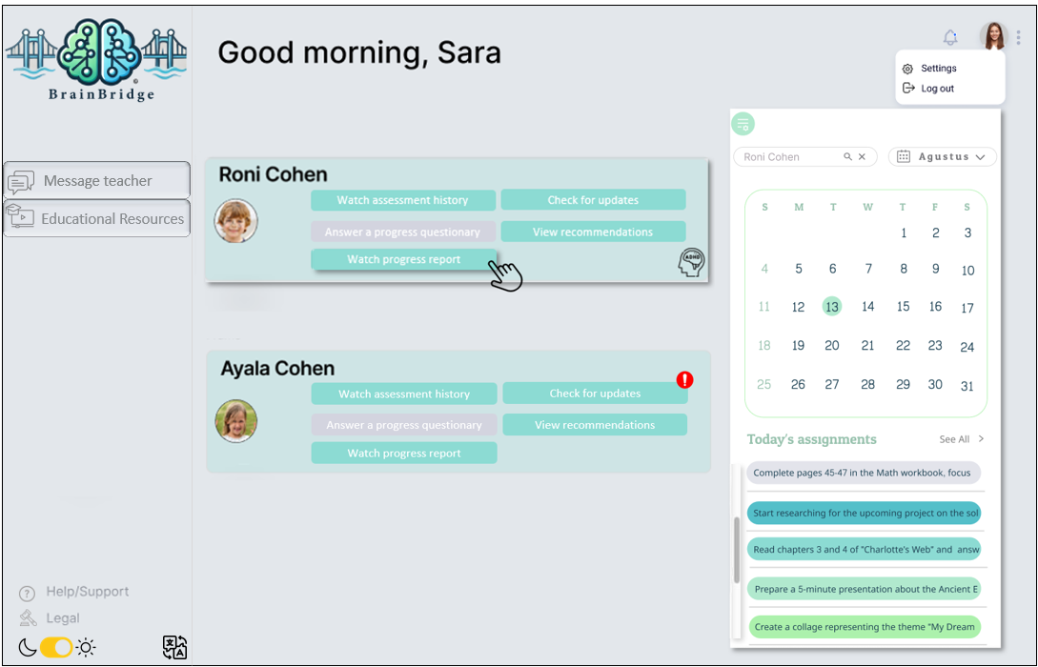

**Primary User:** The user of this screen is a parent. Using the dashboard to stay updated on their child’s educational progress and activities.

**Functionalities and User Capabilities:**

1. **Student Interaction Panel:**

* **Watch Assessment History:** Allows parents to view historical assessment data, helping them track their child's academic performance over time.
* **Answer a Progress Questionnaire:** Enables parents to provide feedback on their child’s progress, which can be valuable for teachers in adapting educational strategies.
* **Watch Progress Report:** Offers detailed reports on the student’s academic and behavioral development.
* **View Recommendations:** Parents can view specific educational recommendations tailored to their child’s needs, aiding in targeted support at home.
* **Check for Updates:** Alerts parents to new updates or important notifications regarding their child’s education, ensuring they are always informed.

1. **Sidebar Menu:**

* **Message Teacher:** Facilitates direct communication with the teacher, making it easy for parents to discuss concerns or ask questions about their child’s progress.
* **Educational Resources:** Provides access to resources that can help parents support their child's learning outside of school.
* **Help/Support and Legal:** Links at the bottom left offer support and legal information, ensuring that teachers can access assistance or necessary documentation related to the platform.
* **Light and Dark Mode:** Allows to choose between light and dark themes.
* **Accessibility :** Enables to change the interface language.

1. **Calendar and Daily Assignments:**

* **Calendar View:** Displays the current month with marked dates for school events and summarizes the tasks and homework assigned to the student for the current day, helping parents ensure that their child completes their assignments on time. Allows search by child's name/ a certain event.

### 5.5.3 Daily Planner and Activity Tracker

**Primary User:** The primary user of this screen is a Student. This child-focused dashboard is designed to foster independence and improve concentration through structured activities and visual aids. It supports children in organizing their daily tasks, enhances their ability to follow schedules, and helps track their mood and progress in a fun and engaging way.

**Functionalities and User Capabilities:**

* **Current Task Display:**
  + **Visual Timer:** Includes a clock showing the current time and a visual representation of the current task (e.g., having dinner), along with the time it's scheduled. This visual aid helps the child keep track of their schedule and understand how much time is allocated for each task.
* **Task List:**
  + **Daily Tasks:** Lists tasks with checkboxes and specified time durations, which helps the child understand what needs to be done and how much time each task should take.
  + **Interactive Elements:** Tasks can be checked off when completed, that provides a sense of accomplishment and helps motivate the child to continue with subsequent tasks.
  + **Star Ratings:** Tasks are rated with stars, when a task is completed the star worth points go to the bar on the right, which can motivate the child to complete these tasks to earn rewards or recognition.
* **Mood Tracker:**
  + **How am I feeling today?:** Allows the child to express their current mood by selecting an emoji. This feature helps in monitoring the child's emotional state, which can be important for adjusting tasks and providing additional support. After choosing a state a questionnaire will be opened once a week for gathering more info about the process.
* **Educational and Support Tools:**
  + **View Recommendations:** Access personalized recommendations, which include activities or tips tailored to the child’s needs recognized using the assessments.
  + **Do a New Assessment:** Option to start a new assessment, is the teacher opened it.
* **Support and Accessibility:**
  + **Help/Support:** Easy access to help or support features if the child encounters difficulties or has questions about the tasks.
  + **Light and Dark Mode:** Allows to choose between light and dark themes.
  + **Accessibility :** Enables to change the interface language.

**Design and Usability:**

* **Colorful and Engaging Interface:** The use of bright colors and large, friendly icons makes the interface appealing and easy to navigate for children.[35]
* **Simplified Layout:** The layout is straightforward, minimizing distractions and making it easier for children with concentration difficulties to focus on one item at a time.

### 5.5.4 **Watch recommendations**

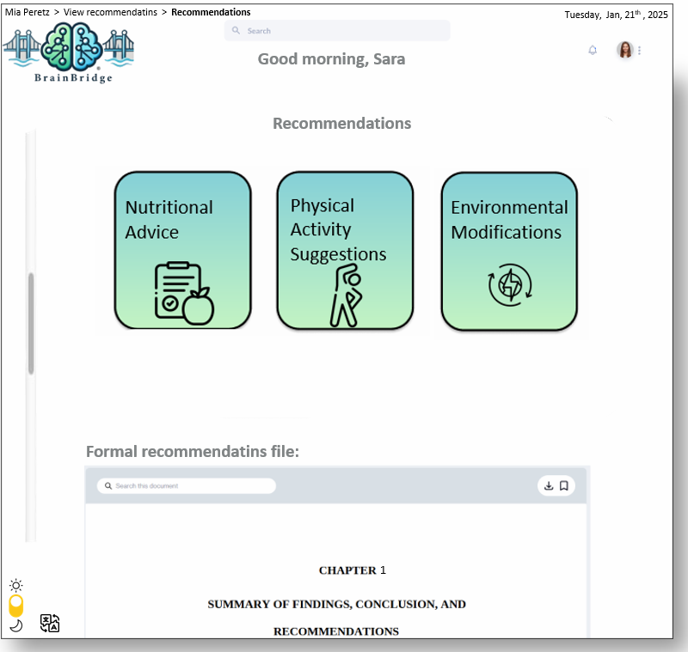

**Primary User:** This interface is accessible to parents, teachers, and students, allowing each user to view tailored recommendations based on the student’s needs and assessment results.

**Functionalities and User Capabilities:**

1. **Recommendation Categories:**

* **Educational Strategies:** Suggestions on effective learning approaches.
* **Behavioral Interventions:** Techniques to manage or improve behavior.
* **Nutritional Advice:** Tips on diet that can enhance cognitive function.
* **Physical Activity Suggestions:** Recommendations on exercises that can help focus and energy management.
* **Mental Health Support:** Resources and strategies for emotional well-being.
* **Technological Tools:** Tools and apps to assist in learning and organization.
* **Social Skills Development:** Activities and tips to enhance social interactions.
* **Environmental Modifications:** Changes to the physical learning environment to improve concentration.

1. **Accessibility and Support Tools:**

* **Easy Navigation:** Users can navigate through various recommendations using the visual tiles, making the information easy to access and digest.
* **Search Functionality:** Allows users to search through the recommendations for specific topics or keywords.
* **Formal Recommendations File:** A detailed document is available which provides a formal record of all recommendations, supporting detailed review and follow-up.
* **Current Date Display:** Keeps users aware of the current date, adding to the usability of the platform for planning and scheduling.
* **Settings Access:** Quick links to settings allow users to customize their experience, manage account settings, and log out.

1. **User Interface Options:**

* **Light/Dark Mode Toggle:** Enhances visual comfort by allowing users to switch between light and dark themes based on their preference or ambient light conditions.
* **Language Switch:** Supports multiple languages, making the platform accessible to non-English speakers or users who prefer content in their native language.
* **Export Function:** Users can export the recommendations document for offline reading or to share with others who may not have direct access to the platform.

### 5.5.5 Nutritional Recommendations

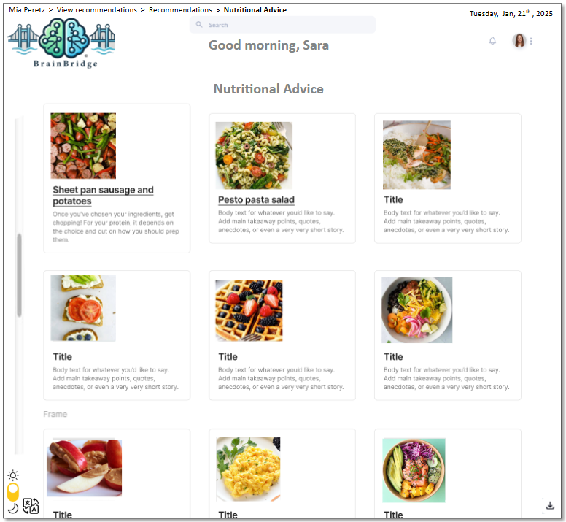

**Primary User:** This interface is accessible to parents, teachers, and students, allowing each user to view tailored food recommendations based on the student’s needs and assessment results.

**Functionalities and User Capabilities:**

1. **Nutritional Advice Section:**
   * **Visually Appealing Food Cards:** Each card displays a healthy meal with an attractive image to engage users. This visual presentation makes the information more appealing and easier to browse.
   * **Detailed Descriptions:** Clicking on each card opens up more detailed information about the dish, including ingredients, preparation steps, and the specific benefits for children, particularly focusing on how these meals can support cognitive functions and overall well-being.
2. **User Interaction and Accessibility:**
   * **Search Functionality:** Users can search within the nutritional advice section for specific dishes or ingredients, making it easy to find suitable meal ideas that align with dietary needs or preferences.
   * **Language and Mode Customization:** The interface allows switching between light and dark modes for better visual comfort and includes language options to cater to diverse users.
   * **Date Display:** The current date is prominently displayed, helping users remain oriented in time, especially when planning meals or educational activities.
   * **Settings Access:** Quick links to settings allow users to customize their experience, manage account settings, and log out.

**3. User Interface Options:**

* **Light/Dark Mode Toggle:** Enhances visual comfort by allowing users to switch between light and dark themes based on their preference or ambient light conditions.
* **Language Switch:** Supports multiple languages, making the platform accessible to non-English speakers or users who prefer content in their native language.
* **Export Function:** Users can export the recommendations document for offline reading or to share with others who may not have direct access to the platform.

**5.5.6 Teachers statistics page**

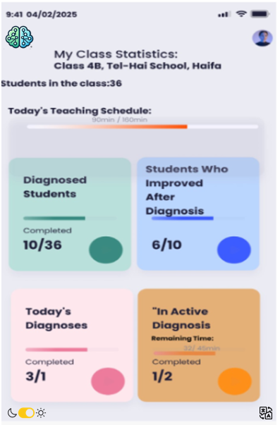

**Primary User:** This interface is accessible to teachers, providing them with details about the progress and performance of their classes and individual students

**User Functions and Capabilities:**

1. **Overview of Class Statistics:**

* **Student Indicators:** Displays key indicators such as the number of students diagnosed, students who showed improvement after diagnosis, and the status of active diagnoses.
* **Visual Indicators:** Sound cards display data in an easy-to-read format, highlighting important trends and progress within the classroom.

1. **Teaching Schedule:**

* **Today's Schedule:** Provides a summary of the teacher's planned teaching duration vs. the time remaining, helping teachers manage their classroom activities effectively.

1. **User Interaction and Accessibility:**

* **Dynamic progress bars:** Each metric includes a progress bar to visually represent completion rates (e.g., diagnosed students, active diagnoses).
* **Interactive insights:** Teachers can click a card to delve into more specific data, such as which students are included in each metric.
* **Responsive Design:** Optimized for use on both mobile and desktop, ensuring easy access to different teaching environments.

1. **User Interface Options:**
   * + - **Light/Dark Mode Toggle:** Enhances visual comfort by allowing users to switch between light and dark themes based on their preference or ambient light conditions.
       - **Language Switch:** Supports multiple languages, making the platform accessible to non-English speakers or users who prefer content in their native language.

### 5.5.7 Login & Register screen

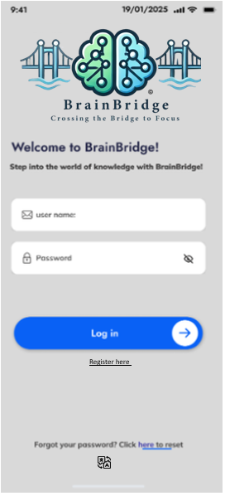

**Primary User:** This interface is accessible to parents, teachers, and students, allowing each user to securely register and log in to the system.

**Functionalities and User Capabilities:**

1. **Secure Login:**

* **Input Fields:** Includes fields for entering the username (email) and password.
* **Password Visibility Toggle:** Users can toggle the visibility of their password to avoid errors while typing.
* **Login Button:** A prominent "Log In" button enables users to access the system after entering valid credentials.

1. **Account Recovery:**

* **Forgot Password Link:** Provides a link to reset the password in case users forget their login credentials. Clicking the link redirects users to a password recovery page.

1. **New User Registration:**

* **Register Option:** For new users, the page includes an option to navigate to the registration screen to create a new account.

1. **Responsive Design:**

* The interface is optimized for various devices, ensuring accessibility on both desktop and mobile.

1. **Additional Features:**

* **Welcome Message:** Displays a welcoming message to introduce users to the system and encourage interaction.
* **Feedback for Incorrect Login:** Provides error messages for incorrect username or password entries.

1. **User Interface Options:**
   * + - **Light/Dark Mode Toggle:** Enhances visual comfort by allowing users to switch between light and dark themes based on their preference or ambient light conditions.
       - **Language Switch:** Supports multiple languages, making the platform accessible to non-English speakers or users who prefer content in their native language.

## 6. Testing plan

Our testing plan will focus on 4 main parts: the frontend, backend, API, and data analysis.

Frontend: We will test how the system looks and works for users. This includes checking if pages load quickly, buttons and forms work properly, and the interface supports different languages. We will decide on the testing tool later, but for now, we plan to include both automated and manual testing approaches.

Backend: Here, we will check if everything behind the scenes works well, like saving data, syncing in real time, and showing progress reports.

API Testing We will test the connection between the frontend and backend using Postman. This includes making sure data is sent and received correctly in JSON format.

Data Analysis: We will check if the system generates accurate reports and recommendations. We will also look at stats like task completion and make sure everything is calculated right.

This plan will help us make sure everything runs smoothly and gives users a good experience.

# 

**Enhanced Test Cases**

| **Test ID** | **Module** | **Tested Function** | **Action** | **Expected Result** |
| --- | --- | --- | --- | --- |
| 1 | Frontend | Login (Enter for example  id: nil_adar password: 123456ab) | Enter a valid username and password and submit the form. | User passed to his Home Page, successful message is displayed. |
| 2 | Frontend | Login (Enter for id: nil_adar password: -x) | Enter not valid username or password and submit the form | user remains on the Login Page, and an error message "Invalid Details, please try again." is displayed. |
| 3 | Frontend | Student Profile check | Click on a students profile in teacher page | Displays student details including personal information, assigned tasks, and recent assessments . |
| 4 | Frontend | Parent Questionnaire Page check | accesses the Questionnaire page from the parent page. | Questionnaire questions loads fully functional, allowing inputs. |
| 5 | Frontend | Task Management add new task | Teacher adds a new task for students , sets a deadline, and assigns it to multiple students.. | Task is successfully added to each student’s profile, message , DB is updated . |
| 6 | Frontend | Multi Language System check | Change the system language from English to Hebrew | All interface texts, including buttons and labels, switch to Hebrew immediately. |
| 7 | Back-End | Synchronization- change in student progress) | Update a student progress on a task in the teacher's interface. | The update is reflected real-time in the parent's interface and in DB |
| 8 | Back-End | Update Task Status | Mark a task as complete from a student task list. | Task status updates are compiled and synchronized across all user interfaces in time. |
| 9 | Api | Generate Student Report | Select a student and generate a report based on the latest assessments. | A detailed report generated showing progress graphs and statistics, available for download. |
| 10 | API | Integrate External Diagnosis(Nodus) | Check the integration with the external system. After finishing assessment, Nodus provides diagnostic results for students. | External system is successfully connected and delivers diagnostic information . |
| 11 | Frontend | Questionnaire Submission | A parent submits a progress questionnaire | Data updates successfully and modifies the child’s recommended interventions |
| 12 | Backend | Dynamic Recommendation Adjustment | A teacher submits a progress update indicating improved focus | The recommendation algorithm recalibrates future suggestions |

## 7. Design thinking - appendices

**7.1 Interviews**

| **Pre-Solution Interview with a Teacher Marina from Nesher**  **Interviewer:** Thank you for joining us today. Could you describe some of the challenges you face daily in teaching students, particularly those with attention disorders?  **Teacher:** One of the biggest challenges is keeping these students engaged. They have diverse needs, and it’s tough to address them all effectively, especially in larger classes. There's also the issue of quickly identifying who needs what kind of support, as attention disorders manifest differently across students.  **Interviewer:** How do you currently identify and manage these diverse needs?  **Teacher:** It’s mostly based on observation and sometimes feedback from parents. However, it's not very systematic, and we lack the tools to do quick assessments or to continuously monitor progress in a structured way.  **Interviewer:** What kind of support do you find most effective for engaging students with attention disorders?  **Teacher:** Visual aids, interactive activities, and anything that can be gamified tend to work well. But again, the lack of tailored resources and the time to individualize learning materials for each student is a significant barrier.  **Interviewer:** What would you wish for in an ideal solution?  **Teacher:** A tool that could help me understand each student’s specific challenges in real-time would be invaluable. Something to help me track their progress and adapt my teaching methods to their current state would make a real difference.  **Interviewer:** Considering the tools you currently have, what additional features or support do you think could make these tools more effective for managing students with attention difficulties?  **Teacher:** I think having more dynamic tools that could adapt to each student's progress would be incredibly useful. For instance, tools that update their strategies based on ongoing assessments would help us keep the interventions fresh and effective.  **Interviewer:** How do you usually gather information or feedback about the effectiveness of the strategies you employ in your classroom?  **Teacher:** It's mostly through observation and sometimes through informal feedback sessions with students. I also discuss with parents during meetings to get their perspective. However, a more structured way of gathering this feedback would definitely help in making more informed decisions.  **Interviewer:** In terms of resources, what kind of support do you feel you need the most to help students with attention difficulties?  **Teacher:** Professional development on understanding attention difficulties better and training on specific intervention strategies would be great. Also, having access to a repository of activities and digital tools that are designed for different types of learners would be invaluable.  **Interviewer:** Finally, what are the biggest barriers you face when trying to implement new tools or strategies in your classroom?  **Teacher:** Time is a big one; there's never enough time to properly integrate new tools and measure their effectiveness. Funding is another issue; often, we find good tools but they are too expensive for our school's budget. |
| --- |

### 

| **Pre-Solution Interview with a Student Itai, 10 years old from Yokneam**  **Interviewer:** Hi there! We'd like to know about your experience at school. Can you share what helps you focus better in class?  **Student:** I like it when we do activities that are fun and when I get to use my hands or move around. Sitting for too long without doing something interesting makes it hard for me to pay attention.  **Interviewer:** Do you feel that your teachers understand what you need to succeed in school?  **Student:** Sometimes, but I think it’s hard for them because there are many students, and everyone needs different things. I get more help at home because my mom talks to my teacher a lot.  **Interviewer:** What would make school better for you?  **Student:** If there were more games and activities related to what we need to learn, that would be cool. Also, if there was a way for my teacher to know when I don’t understand something, so they could help me right away.  **Interviewer:** Thank you for sharing that with us!  **Interviewer:** Can you tell me about a time when you felt really engaged in a classroom activity? What made it engaging for you?  **Student:** Yeah, there was this one time we did a science project where we had to build stuff. I liked it because I could move around and use my hands, and I didn't have to sit still for too long.  **Interviewer:** Do you use any apps or tools in school or at home to help you with your homework or tasks?  **Student:** My mom set up a timer app on my tablet that helps me keep track of doing homework. It’s kind of fun because it turns into a game where I try to beat the timer.  **Interviewer:** That’s a great suggestion. How do you think these games could help you with your homework?  **Student:** If the games could show me how to solve problems while I'm playing, I might understand better. Also, if there was a way the game could remind me about my homework due dates and help me organize them, I wouldn’t forget them as much.  **Interviewer:** Do you think having a personal dashboard in a game where you could see your assignments and due dates would help?  **Student:** Yeah, that would be awesome! If it could show me what's due next and maybe even break down the steps I need to do for each assignment, it would be really helpful.  **Interviewer:** And would you like these games to be competitive or more about collaborating with classmates?  **Student:** Maybe both? It could be fun to have some games where I try to beat my own score, and others where I work with my friends to solve something together.  **Interviewer:** Do you ever feel like your teachers understand when you're having a tough day or finding it hard to pay attention?  **Student:** Sometimes, but not always. I wish there was a way they could know when I'm struggling without me having to tell them because that’s sometimes hard to do.  **Interviewer:** Thank you for sharing that with us! It’s really helpful to know what works for you and what could be better. |
| --- |

**7.2 persona**

| **Profile:**   * Name: Marina * Age: 45 * Location: Nesher, Israel * Occupation: Middle School Teacher * Educational Background: B.A. in Education, Specialization in Special Education.   **Background:** Marina has been teaching for over a decade, primarily focusing on students aged 10-13. Her experience in special education helps her manage a diverse classroom with varying needs, particularly focusing on students with attention disorders such as ADHD.  **Challenges:**   * Struggles to keep students with diverse needs engaged due to the large class size. * Lacks systematic tools for quick assessment and continuous monitoring of students with attention difficulties. * Finds it challenging to individualize learning materials due to time constraints.   **Needs:**   * A tool that provides real-time, individualized student performance data to tailor teaching methods dynamically. * Systematic and structured tools for assessing student needs and monitoring their progress. * Training and resources to effectively use new tools and strategies in her teaching.   **Goals:**   * To enhance engagement and learning outcomes for students with attention disorders. * To reduce stress and increase effectiveness in managing large and diverse classes. * To integrate more interactive and gamified learning tools that cater to various learning needs.   **Technology Comfort Level:** Comfortable with using educational technology and open to integrating new tools that streamline classroom management and enhance student engagement. |
| --- |

| **Profile**:   * Name: Itai * Age: 10 * Location: Yokneam, Israel * Grade: 5th * Interests: Science, video games, freezing things as experiments and outdoor activities   **Background**: Itai is a vibrant and curious child who enjoys hands-on activities and interactive learning. However, he faces challenges with attention and tends to forget homework assignments or struggles to stay focused during prolonged periods of traditional teaching.  **Challenges**:   * Quickly loses interest during passive learning activities. * Struggles with organizing and remembering homework assignments. * Occasionally feels overlooked in the busy classroom environment.   **Needs**:   * Interactive and engaging educational tools that incorporate elements of play and movement. * A personal organizational tool to help keep track of homework and other school-related tasks. * Immediate feedback and assistance during learning activities to keep him engaged and supported.   **Goals**:   * To become more engaged and successful in his learning activities. * To feel more confident in managing his schoolwork and deadlines. * To have a more personalized learning experience that adapts to his pace and style.   **Technology Comfort Level**: Very comfortable with digital devices. Enjoys using apps, particularly games, and finds technology a helpful aid in his learning and daily routines. |
| --- |

**7.3 Empathy map**

**Empathy Map for Itai, 10-Year-Old Student**

| **Think**   * "I wish class was more fun like the games I play." * "Why don't I often understand my homework until my mom helps me??" * "I'm so bored, why aren't we doing something fun." | **Does**   * Participates actively in hands-on activities and games. * Uses a timer app to manage homework tasks. * Sometimes forgets assignments and struggles with organization. |
| --- | --- |
| **Says**   * "I like it when we can do something fun or move around in class." * "I forget my homework a lot." * "It’s hard to pay attention when we have to sit still for a long time." | **Feel**   * Frustrated when unable to follow along or remember tasks. * Enthusiastic about interactive and engaging learning methods. * Anxious about speaking up in class when he’s falling behind. |

**Empathy Map for Marina, Teacher**

| **Think**   * "How can I better support each student’s unique learning needs?" * "I need tools that help me track and adapt to my students' progress in real-time." * "It’s challenging to balance the curriculum with the individual needs of my students." | **Does**   * Observes students to identify those who might be struggling. * Uses traditional methods mixed with some interactive tools to teach. * Seeks out professional development opportunities to better understand attention disorders. |
| --- | --- |
| **Says**   * "I wish I had a way to know exactly what each student needs." * "There’s never enough time to individualize my teaching approach." * "I try to use different methods to see what works best for engaging my students." | **Feel**   * Overwhelmed by the diverse needs of her students, especially in large classes. * Motivated to find better ways to support students with attention difficulties. * Concerned about not having adequate resources or time to implement new strategies effectively. |

## 8. Questionnaires

**8.1 Progress Monitoring Questionnaire (Teacher/Parent/Child Versions)**

| **Teacher Version**  Student Name: _______ Date: _______ Class: _______  Academic Performance   1. How often does the student complete assigned tasks within the given time?   [1] Never  [2] Rarely  [3] Sometimes  [4] Often  [5] Always   1. The student's ability to maintain focus during lessons has improved:   [1] Strongly Disagree  [2] Disagree  [3] Neutral  [4] Agree  [5] Strongly Agree   1. The student's organization of materials and workspace has improved:   [1] Strongly Disagree  [2] Disagree  [3] Neutral  [4] Agree  [5] Strongly Agree  Physical Observations   1. The student's energy level seems appropriate for learning activities:   [1] Never  [2] Rarely  [3] Sometimes  [4] Often  [5] Always   1. The student appears alert and well-rested:   [1] Never  [2] Rarely  [3] Sometimes  [4] Often  [5] Always   1. How has the student responded to their current classroom seating placement? [1] It negatively affects focus [2] No noticeable impact [3] It slightly improves focus [4] It significantly improves focus   Physical Activity Response   1. Engagement in assigned physical activities: [1] Refuses to participate [2] Minimal participation [3] Moderate participation [4] Good participation [5] Excellent participation 2. Has the student shown improved concentration after physical activity sessions? [1] No improvement [2] Slight improvement [3] Moderate improvement [4] Significant improvement | **Parent Version**  Child Name: _______ Date: _______  Daily Routine Observations   1. Morning routine completion:   [1] Needs constant reminders  [2] Needs several reminders  [3] Needs occasional reminders  [4] Needs minimal reminders  [5] Self-directed   1. Adherence to recommended diet plan:   [1] Never follows  [2] Rarely follows  [3] Sometimes follows  [4] Usually follows  [5] Always follows  Physical Activity Engagement   1. Participation in recommended activities:   [1] Refuses  [2] Reluctant  [3] Neutral  [4] Willing  [5] Enthusiastic   1. How would you describe your child’s current physical activity level?   [1] Sedentary (No activity)  [2] Low (Minimal movement)  [3] Moderate (Some structured activity)  [4] High (Regular physical activity)  [5] Very high (Daily structured exercise)   1. Have you noticed an improvement in your child's ability to focus after physical activity?   [1] No improvement  [2] Slight improvement  [3] Moderate improvement  [4] Significant improvement  Nutritional Plan Adherence   1. Following recommended meal schedule:   [1] Never follows  [2] Rarely follows  [3] Sometimes follows  [4] Usually follows  [5] Always follows   1. My child's eating habits have improved:   [1] Significant worsening  [2] Slight worsening  [3] No change  [4] Slight improvement  [5] Significant improvement  Home Behavior   1. How often does your child complete homework without constant reminders?   [1] Never  [2] Rarely  [3] Sometimes  [4] Often  [5] Always   1. My child's sleep schedule has improved:   [1] Strongly Disagree  [2] Disagree  [3] Neutral  [4] Agree  [5] Strongly Agree   1. How would you rate your child’s overall energy levels throughout the day?   [1] Very low (constantly tired)  [2] Low (often sluggish)  [3] Moderate (somewhat alert)  [4] High (alert most of the time)  [5] Very high (energetic and engaged) |
| --- | --- |
| **Child Information**   * Name: ________ * Date: ________   How I Feel   1. I can focus better in class:   [1] Not at all  [2] A little bit  [3] Sometimes  [4] Most of the time  [5] All the time   1. I feel less tired during the day:   [1] Not at all  [2] A little bit  [3] Sometimes  [4] Most of the time  [5] All the time   1. Do you feel your classroom seat helps you focus? [1] No, I get distracted more [2] It makes no difference [3] It helps a little [4] It helps a lot 2. How do you feel about the foods you eat now? [1] I don’t like them at all [2] I like some of them [3] I like most of them [4] I enjoy them a lot 3. Do you think physical activity helps you focus better? [1] Not at all [2] A little bit [3] Sometimes [4] Most of the time [5] Always |  |

**8.2 Recommendation Input Form**

| **Child Health Information Form**  Sleep Patterns   * Sleep quality (self-reported or parent-reported): □ Poor □ Fair □ Good □ Very good □ Excellent   class information   * Common school-related challenges (select all that apply): □ Difficulty concentrating in class □ Trouble following instructions □ Frequently forgetting homework □ Difficulty staying organized □ Struggles with transitions between tasks □ Easily frustrated by schoolwork □ Other: ______   Dietary Information   1. Food allergies (select all that apply): □ None □ Fish/Seafood □ Nuts □ Dairy □ Eggs □ Other: _______ 2. Current daily diet includes: □ Breakfast □ Morning snack □ Lunch □ Afternoon snack □ Dinner □ Evening snack 3. Current supplements: □ None □ Iron □ Zinc □ Omega-3 □ Other: _______   Food Preferences   * Likes (select all that apply): □ Fruits □ Vegetables □ Meat □ Fish □ Dairy □ Whole grains □ Sweets □ Other: _______ * Dislikes (select all that apply): □ Fruits □ Vegetables □ Meat □ Fish □ Dairy □ Whole grains □ Sweets □ Other: _______   Physical Activity Preferences   1. Preferred activities (select all that apply): □ Dance/Yoga □ Martial arts □ Aerobics □ Team Games 2. Best time for physical activity: □ Morning □ Afternoon □ Evening   3. Physical activity level:  [1] Very low (Less than 30 min/day)  [2] Low (30-60 min/day)  [3] Moderate (1-2 hours/day)  [4] High (2-3 hours/day)  [5] Very high (More than 3 hours/day)  Family & Home Environment  Household noise level during learning or homework:  □ Quiet □ Moderate □ Noisy  Learning Preferences & School Performance   * Preferred learning style (select all that apply): □ Visual (pictures, videos, diagrams) □ Auditory (listening, discussions, lectures) □ Kinesthetic (hands-on activities, movement-based learning) □ Reading/Writing (books, notes, written assignments) * Subjects the child finds easiest (select all that apply): □ Math □ Science □ Reading □ Writing □ Art/Music □ Social Studies □ Other: _______ * Subjects the child struggles with (select all that apply): □ Math □ Science □ Reading □ Writing □ Art/Music □ Social Studies □ Other: _______ | **Teacher Recommendation Input**  Student Physical Setting   1. Current seating location: □ Front of class □ Middle of class □ Back of class □ Near window □ Near door 2. Student's academic performance (1-5 scale):   Mathematics: [Drop-down 1-5]  Reading: [Drop-down 1-5]  Writing: [Drop-down 1-5]   1. Response to teacher instructions:   [1] Rarely follows  [2] Sometimes follows  [3] Usually follows  [4] Almost always follows  [5] Always follows  Common school-related challenges:   * (select all that apply): □ Difficulty concentrating in class □ Trouble following instructions □ Frequently forgetting homework □ Difficulty staying organized □ Struggles with transitions between tasks □ Easily frustrated by schoolwork □ Other: ______ * How often does the student complete assigned tasks within the given time?   [1] Never  [2] Rarely  [3] Sometimes  [4] Often  [5] Always   * The student's ability to maintain focus during lessons has improved:   [1] Strongly Disagree  [2] Disagree  [3] Neutral  [4] Agree  [5] Strongly Agree |
| --- | --- |
| **Parent about child Information Form**  Physical Information   * Height: [Drop-down in cm] * Weight: [Drop-down in kg] * Age: [Drop-down]   Sleep Patterns   * Bedtime: [Drop-down: HH:MM] * Wake-up time: [Drop-down: HH:MM] * Total sleep duration per night: [Drop-down: Hours]   Screen Time & Digital Media Use   * Most frequently used devices (select all that apply): □ Smartphone □ Tablet □ Computer □ TV □ Gaming console □ Other: _______ * Preferred content type: □ Educational □ Social Media □ Video Games □ Movies/TV Shows □ Other: ______ * Daily screen time (excluding schoolwork): □ Less than 1 hour □ 1-2 hours □ 2-4 hours □ More than 4 hours   Emotional & Behavioral Patterns   * Common emotional states (select all that apply): □ Calm □ Happy □ Anxious □ Frustrated □ Overwhelmed □ Excited □ Other: _______ * Social behavior tendencies: □ Prefers working alone □ Enjoys group activities □ Avoids social interactions □ Struggles with making friends □ Other: _______ * Self-regulation skills: □ Can independently manage emotions □ Needs guidance to manage frustration □ Has frequent emotional outbursts □ Other: _______   5. Family & Home Environment   * Daily routine consistency: □ Very structured and consistent □ Somewhat structured □ Mostly unstructured * Support at home for learning and behavior management: □ Regular parental involvement in homework □ Occasional parental help when needed □ Minimal or no parental involvement |  |

## 9. ChatGpt conversations

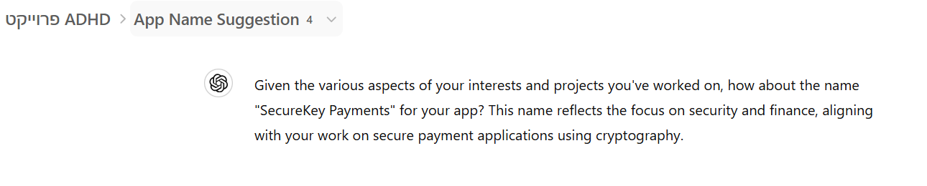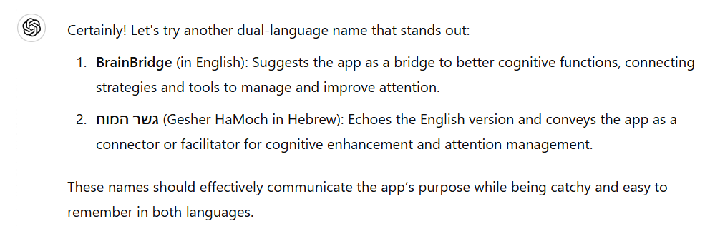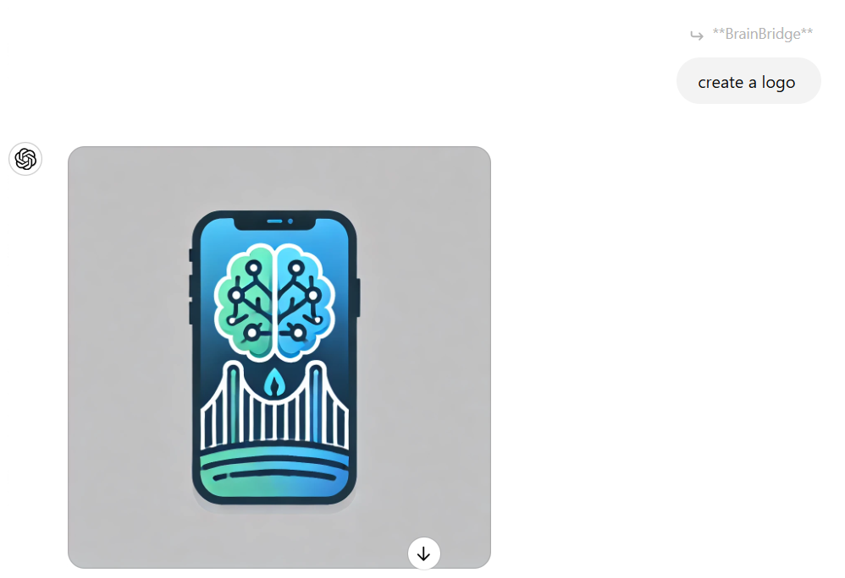

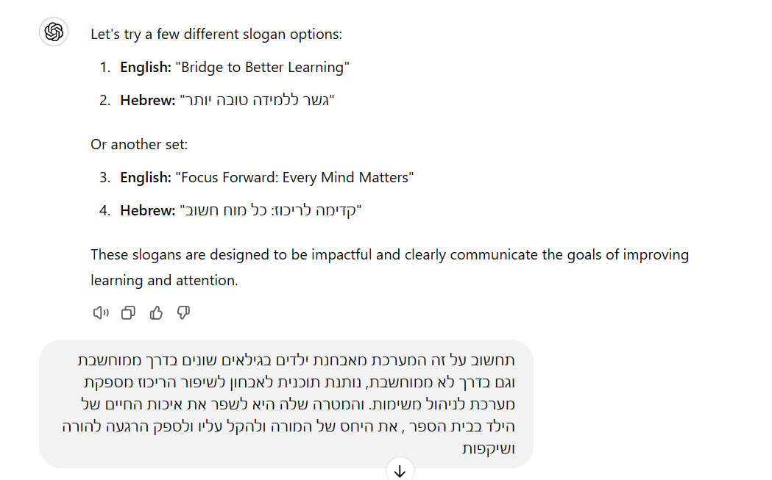

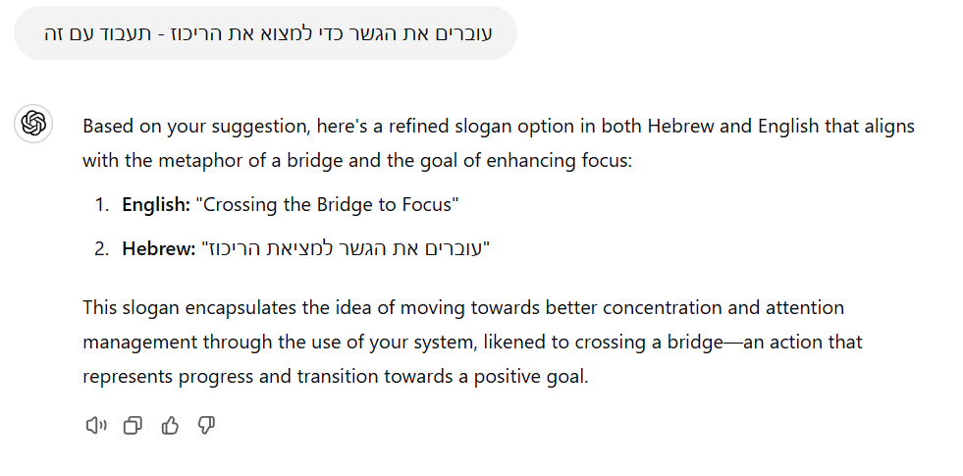

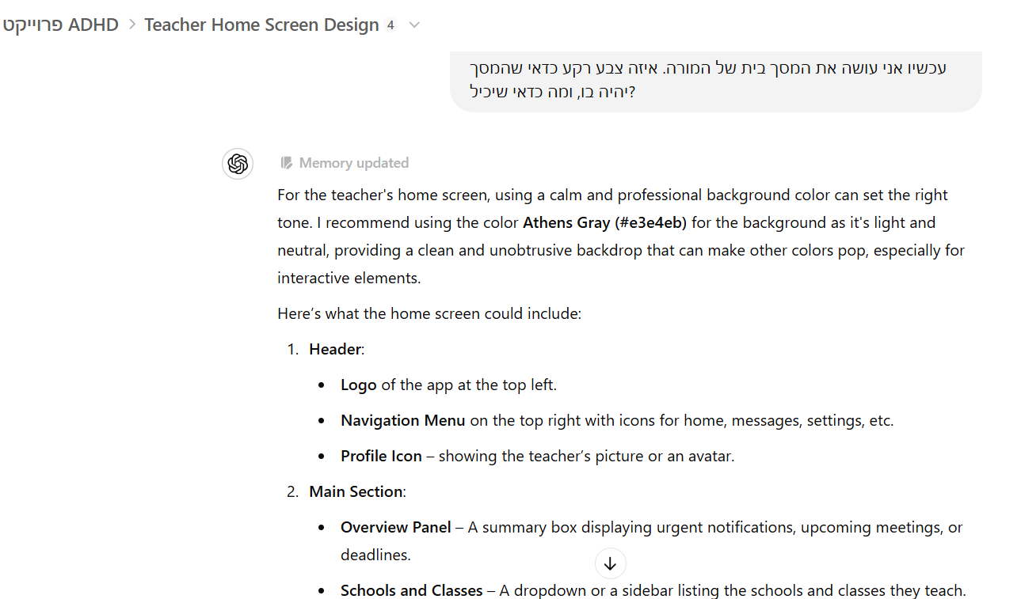

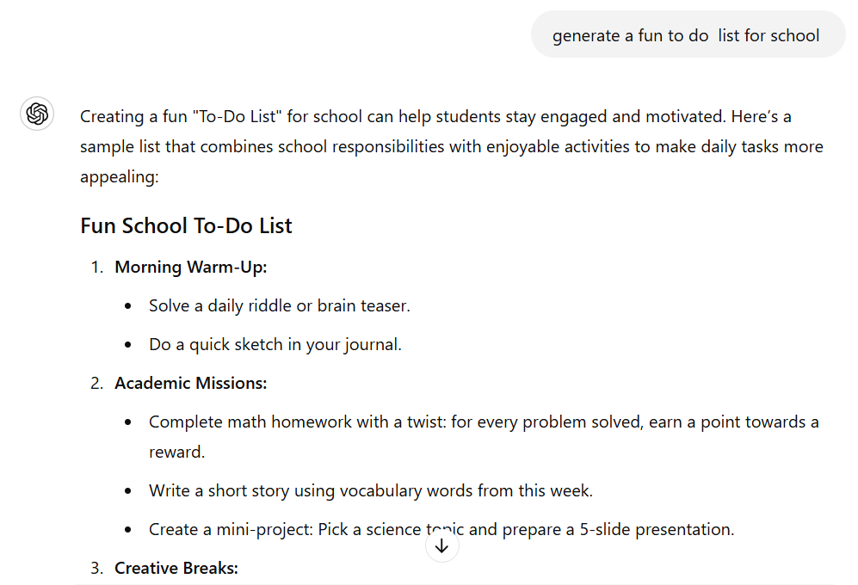

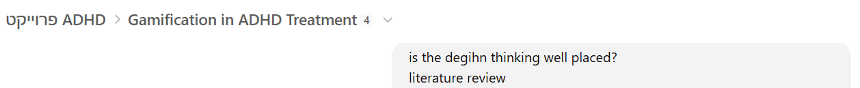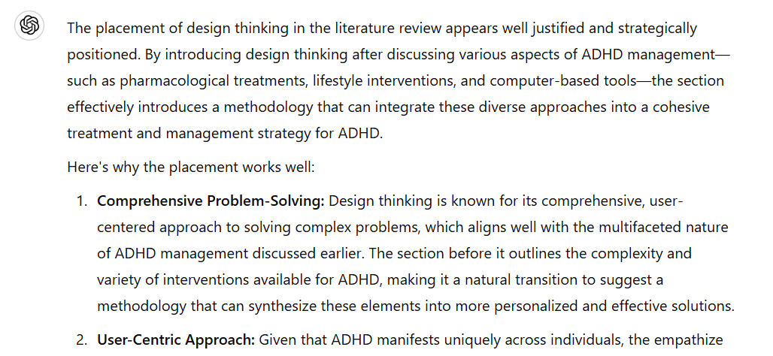

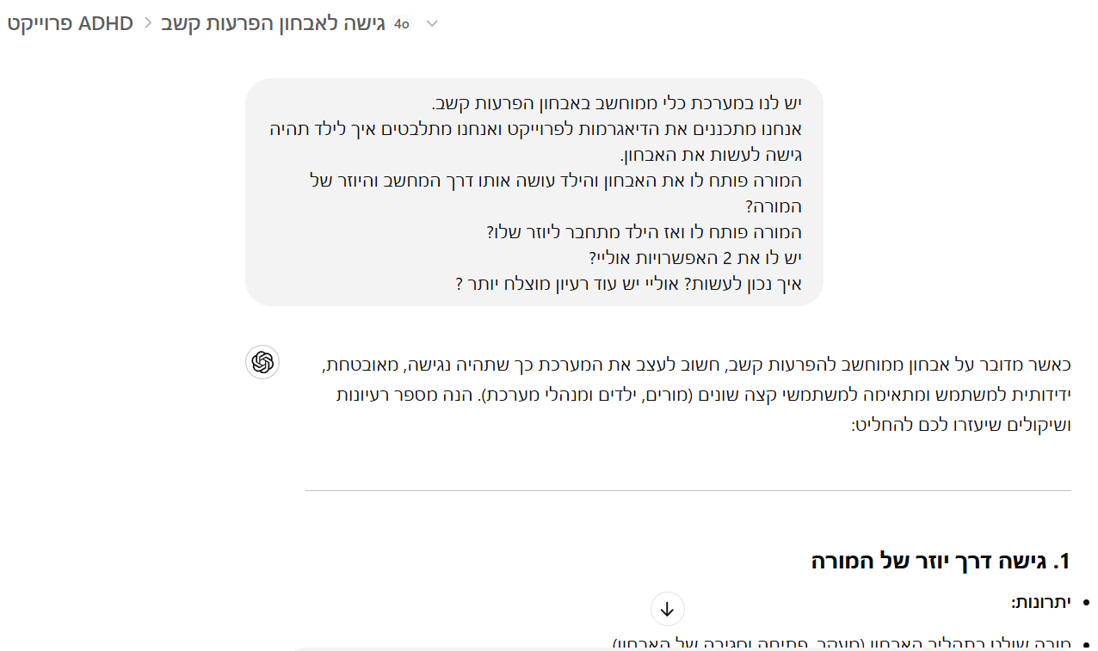

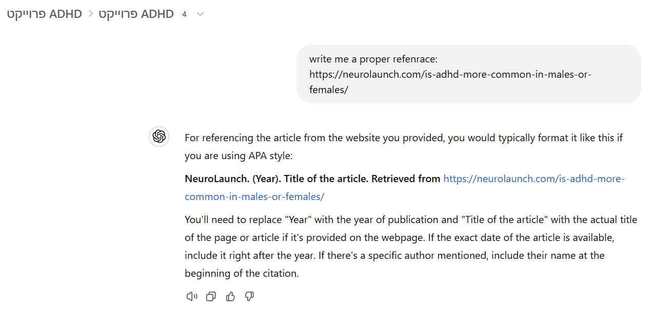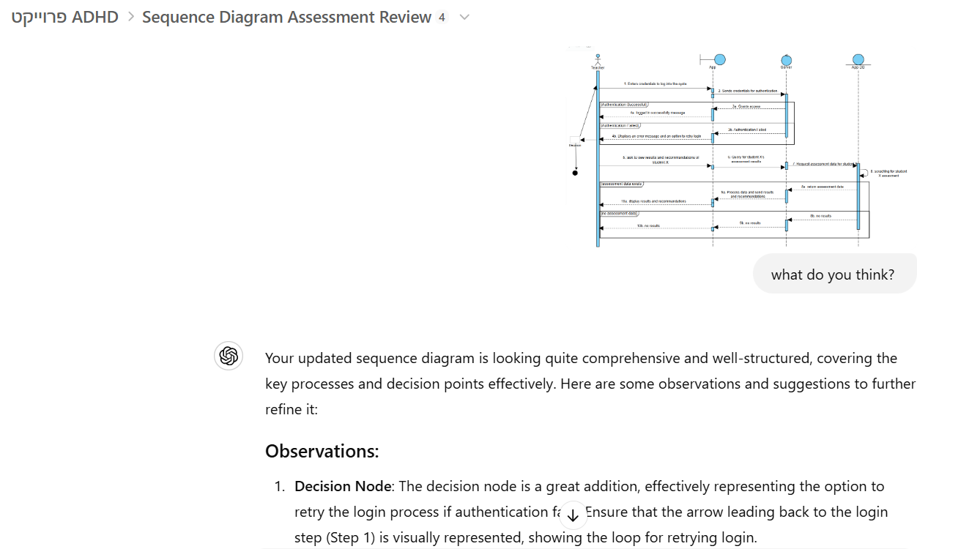

## References

[1] The Effects of Social Media on Dopamine Levels (Neurolaunch). Retrieved from <https://neurolaunch.com/social-media-dopamine/>.

[2] Smith, J., & Brown, K. (2021). The Effects of Digital Overstimulation on Attention and Learning in Children. Frontiers in Psychology. <https://www.frontiersin.org/articles/10.3389/fpsyg.2021.611155/full>

[3] Moore, D. A., Russell, A. E., Arnell, S., & Ford, T. J. (2017). Educators' experiences of managing students with ADHD: a qualitative study. Child: care, health and development, 43(4), 489-498.

[4] Sibley, M. H., Campez, M., Perez, A., Morrow, A. S., Merrill, B. M., Altszuler, A. R., ... & Yeguez, C. E. (2016). Parent management of organization, time management, and planning deficits among adolescents with ADHD. Journal of psychopathology and behavioral assessment, 38, 216-228.

[5] Koro-Ljungberg, M., Bussing, R., Wilder, J., & Gary, F. (2011). Role of communication in the context of educating children with attention-deficit/hyperactivity disorder: Parents’ and teachers’ perspectives. Journal of School Public Relations, 32(1), 41-75.

[6] Biederman, J., DiSalvo, M., Vaudreuil, C., Wozniak, J., Uchida, M., Woodworth, K. Y., ... & Faraone, S. V. (2021). The child behavior checklist can aid in characterizing suspected comorbid psychopathology in clinically referred youth with ADHD. Journal of psychiatric research, 138, 477-484.

[7] American Academy of Pediatrics. (2019). ADHD: Clinical Practice Guideline for the Diagnosis, Evaluation, and Treatment of Attention-Deficit/Hyperactivity Disorder in Children and Adolescents. Pediatrics, 144(4), e20192528.

[8] FamilyEducation. (n.d.). 22 Super Helpful Apps for Kids with ADHD. Retrieved from<https://www.familyeducation.com/kids/neurodiversity/adhd/22-super-helpful-apps-for-kids-with-adhd>

[9] Reynolds, C. R., & Kamphaus, R. W. (2004). Behavior Assessment System for Children (2nd ed.). AGS Publishing.

[10] Viola, A., Balsamo, L., Neglia, J. P., Brouwers, P., Ma, X., & Kadan-Lottick, N. S. (2017). The Behavior Rating Inventory of Executive Function (BRIEF) to Identify Pediatric Acute Lymphoblastic Leukemia (ALL) Survivors At Risk for Neurocognitive Impairment. Journal of pediatric hematology/oncology, 39(3), 174–178. <https://doi.org/10.1097/MPH.0000000000000761>

[11] Martinez, R., & Wighting, M. (2023). Teacher-Student Relationships: Impact of Positive Behavioral Interventions and Supports. Athens Journal of Education, 10(3), 397-410.

[12] Children and Screens. (2021). Attention, Media Use, and Children: Understanding the Impact on Family Dynamics. Children and Screens: Institute of Digital Media and Child Development. Retrieved from <https://www.childrenandscreens.org/learn-explore/research/attention-media-use-and-children/>

[13] Developing Minds. (2021). Attention and concentration challenges in children and young people: Long-lasting impacts on education, social, and work outcomes. Developing Minds Educational Psychology and Learning. Retrieved from <https://developingminds.net.au/articles-for-professionals/2021/8/17/attention-and-concentration-challenges-in-children-and-young-people>.

[14] Francisco, C. D., & Celon, L. C. (2020). Teachers' Instructional Practices and Its Effects on Students' Academic Performance. Online Submission, 6(7), 64-71.

[15] ADDitude Editors. (2023). A Brief History of ADHD: From 1798 to Today. ADDitude Magazine. Retrieved from<https://www.additudemag.com/history-of-adhd/>

[16] Government of Israel. (n.d.). *Children with ADHD*. Retrieved February 8, 2025, from <https://www.gov.il/he/pages/children-adhd>

[17] Psychologim. (n.d.). *הפרעות קשב וריכוז*. Retrieved February 8, 2025, from [https://psychologim.com/הפרעות-קשב-וריכוז/](https://psychologim.com/%D7%94%D7%A4%D7%A8%D7%A2%D7%95%D7%AA-%D7%A7%D7%A9%D7%91-%D7%95%D7%A8%D7%99%D7%9B%D7%95%D7%96/)

[18] Clalit Health Services. (n.d.). *הפרעת קשב וריכוז (ADHD) אצל ילדים: המדריך המלא*. Retrieved February 8, 2025, from<https://www.clalit.co.il/he/your_health/kids/childs/Pages/tova.aspx>

[19] Shen, F., & Zhou, H. (2024). Advances in the etiology and neuroimaging of children with attention deficit hyperactivity disorder. Frontiers in Pediatrics, 12, 1400468.

[20] Ra, C. K., Cho, J., Stone, M. D., De La Cerda, J., Goldenson, N. I., Moroney, E., ... & Leventhal, A. M. (2018). Association of digital media use with subsequent symptoms of attention-deficit/hyperactivity disorder among adolescents. Jama, 320(3), 255-263.

[21] Lawrenson, J. G., Hull, C. C., & Downie, L. E. (2017). The effect of blue‐light blocking spectacle lenses on visual performance, macular health and the sleep‐wake cycle: a systematic review of the literature. Ophthalmic and Physiological Optics, 37(6), 644-654.

[22] Kostić, J. O., & Ranđelović, K. R. (2022). Digital distractions: Learning in multitasking environment. Psychological Applications and Trends, 301-304.

[23 ] Saccaro, L. F., Schilliger, Z., Perroud, N., & Piguet, C. (2021). Inflammation, anxiety, and stress in attention-deficit/hyperactivity disorder. Biomedicines, 9(10), 1313.

[24] Sycamore, B. Viewing ADHD’s Impact on Children’s Social Development Through the Lens of Peer Rejection. Family Perspectives, 6(1), 1.

[25] Relational Psych Group. (2024). Exploring the Impact of School Stress on Teens' Emotional Well-being. Retrieved from<https://www.relationalpsych.group/articles/exploring-the-impact-of-school-stress-on-teens-emotional-well-being>

[26] Kwon, S. J., Kim, Y., & Kwak, Y. (2018). Difficulties faced by university students with self-reported symptoms of attention-deficit hyperactivity disorder: a qualitative study. Child and adolescent psychiatry and mental health, 12, 1-8.

[27] Faraone, S. V., Biederman, J., Spencer, T., Wilens, T., Seidman, L. J., Mick, E., & Doyle, A. E. (2000). Attention-deficit/hyperactivity disorder in adults: an overview. Biological psychiatry, 48(1), 9-20.

[28] ]NeuroLaunch. (n.d.). Is ADHD more common in males or females? Retrieved from<https://neurolaunch.com/is-adhd-more-common-in-males-or-females/>

[29] ADHD Weekly. (2017, September 14). School Suspension Risk Higher for Students with ADHD. Retrieved from <https://chadd.org/adhd-weekly/school-suspension-risk-higher-for-students-with-adhd/>

[30] The Summit Psychology Clinic. (n.d.). ADHD in Men vs. Women: Why Gender Matters in Diagnosis and Treatment. Retrieved from<https://www.thesummitpsychology.com/blog/adhd-in-men-vs-women-why-gender-matters-in-diagnosis-and-treatment>

[31] NeuroLaunch. (n.d.). ADHD in Women vs. Men. Retrieved from<https://neurolaunch.com/adhd-in-women-vs-men/>

[32]Mechler, K., Banaschewski, T., Hohmann, S., & Häge, A. (2022). Evidence-based pharmacological treatment options for ADHD in children and adolescents. Pharmacology & therapeutics, 230, 107940.- [Evidence-based pharmacological treatment options for ADHD in children and adolescents - ScienceDirect](https://www.sciencedirect.com/science/article/pii/S016372582100142X)

[33] Clalit. (n.d.). Ritalin (Methylphenidate Hydrochloride) for ADHD Treatment. Retrieved from<https://www.clalit.co.il/he/medical/pharmacy/Pages/ritalin_methylphenidate_hydrochloride.aspx?utm_source>

[34] Nazarova, V. A., Sokolov, A. V., Chubarev, V. N., Tarasov, V. V., & Schiöth, H. B. (2022). Treatment of ADHD: Drugs, psychological therapies, devices, complementary and alternative methods as well as the trends in clinical trials. Frontiers in Pharmacology, 13, 1066988. doi:10.3389/fphar.2022.1066988

[35] Lange, K. W., Lange, K. M., Nakamura, Y., & Reissmann, A. (2023). Nutrition in the management of ADHD: A review of recent research. Current Nutrition Reports, 12(3), 383-394. doi:10.1007/s13668-023-00472-9

[36] Research on the limitations of dietary changes for ADHD management. (n.d.). על הקשר בין תזונה והפרעת קשב - קווים ומחשבות. Retrieved from <https://www.kavim-machshavot.com/adhd-diet>

[37] Den Heijer, A. E., Groen, Y., Tucha, L., Fuermaier, A. B., Koerts, J., Lange, K. W., ... & Tucha, O. (2017). Sweat it out? The effects of physical exercise on cognition and behavior in children and adults with ADHD: a systematic literature review. Journal of Neural Transmission, 124, 3-26. doi:10.1007/s00702-016-1593-7

[38] Kankanhalli, A., Taher, M., Cavusoglu, H., & Kim, S. H. (2012). Gamification: A new paradigm for online user engagement.

[39]- Hamari, J., Koivisto, J., & Sarsa, H. (2014, January). Does gamification work?--a literature review of empirical studies on gamification. In 2014 47th Hawaii international conference on system sciences (pp. 3025-3034). Ieee.‏

[40]- da Rocha Seixas, L., Gomes, A. S., & de Melo Filho, I. J. (2016). Effectiveness of gamification in the engagement of students. Computers in Human Behavior, 58, 48-63

[41]Sanders, S. K. ADHD Tech+ Tools: Not a cure but useful scaffolding.

[42]Nouchi, R., Taki, Y., Takeuchi, H., Hashizume, H., Nozawa, T., Kambara, T., ... & Kawashima, R. (2013). Brain training game boosts executive functions, working memory and processing speed in the young adults: a randomized controlled trial. PloS one, 8(2), e55518.

[43] ADHD Behavior Toolbox. (n.d.). Available on the App Store. Retrieved from<https://apps.apple.com/me/app/adhd-behavior-toolbox/id1437791689>

[44] Breethe - Meditation & Sleep. (n.d.). Retrieved from<https://breethe.com>

[45]Mindful Powers. (n.d.). An app designed to help children develop emotional regulation and mindfulness through interactive activities. Retrieved from<https://apps.apple.com/us/app/mindful-powers/id1437112916>

[46] Seesaw. (n.d.). Seesaw helps teachers track student progress and organize tasks, supporting students with ADHD. Retrieved from<https://apps.apple.com/us/app/seesaw/id930565184>

[47] Rostain, A. L., & Ramsay, J. R. (2006). A combined treatment approach for adults with ADHD—results of an open study of 43 patients. Journal of attention disorders, 10(2), 150-159.‏

[48] - Chasanidou, D., Gasparini, A. A., & Lee, E. (2015). Design thinking methods and tools for innovation. In Design, User Experience, and Usability: Design Discourse: 4th International Conference, DUXU 2015, Held as Part of HCI International 2015, Los Angeles, CA, USA, August 2–7, 2015, Proceedings, Part I (pp. 12-23). Springer International Publishing.

[49]Liu, C., & Kaeser, P. S. (2019). Mechanisms and regulation of dopamine release. Current opinion in neurobiology, 57, 46-53.

[50]Basu, S., & Dasgupta, P. S. (2000). Dopamine, a neurotransmitter, influences the immune system. Journal of neuroimmunology, 102(2), 113-124.